ORCHESTRA: A Simulation-Based Human-Centred Multi-Agent Framework for Predictive Maintenance Decision Support in Resistance Spot Welding

Abstract- Predictive maintenance has become an important strategy in smart manufacturing, yet many existing approaches remain limited by their focus on prediction rather than decision support. In resistance spot welding, maintenance decisions require not only the identification of degradation or process instability, but also the selection of an appropriate intervention time under operational constraints. This paper proposes ORCHESTRA, a simulation-based human-centred multi-agent framework for predictive maintenance decision support in resistance spot welding. The framework integrates four agents: a Machine/IoT Agent for condition data representation, an AI Predictive Agent for maintenance urgency estimation, a Human Operator Agent for uncertainty-triggered review, and a Reinforcement Learning Scheduling Agent for proactive maintenance timing. XGBoost is used as the predictive layer to estimate a continuous maintenance urgency score, while Proximal Policy Optimisation is used to select maintenance actions based on severity, uncertainty, resource availability, production load, time since last maintenance, and maintenance cost. The framework was evaluated through a simulation-based proof-of-concept using an adapted resistance spot welding dataset. Results showed that XGBoost provided a strong balance between predictive performance and computational efficiency, with electrode tip temperature and vibration emerging as the most influential predictors. The PPO Scheduling Agent learned a planning-oriented maintenance policy that avoided critical failures and selected proactive maintenance actions. Baseline and ablation results showed that PPO-based scheduling substantially outperformed reactive, preventive, prediction-only, and rule-based strategies, while the full ORCHESTRA framework achieved comparable performance to PPO-only scheduling while adding selective human review. Sensitivity analysis further showed that the framework remained stable under variations in uncertainty threshold, sensor noise, reward weighting, and human intervention frequency. The findings suggest that ORCHESTRA can support the transition from prediction-only maintenance towards a coordinated, human-centred, and context-aware decision-support architecture for smart manufacturing.

Keywords- Predictive Maintenance; Human-in-the-Loop; Multi-Agent Systems; Reinforcement Learning; Maintenance Scheduling; XGBoost; PPO; Resistance Spot Welding; Smart Manufacturing; Industry 4.0

1. Introduction
The transition towards Industry 4.0 has reshaped modern manufacturing by integrating cyber-physical systems, industrial sensors, artificial intelligence, and data-driven decision-making into connected production environments. Within this transformation, predictive maintenance has become an important strategy for improving equipment reliability, reducing unplanned downtime, and supporting more efficient maintenance planning. Rather than relying only on fixed maintenance intervals or reactive repair after failure, predictive maintenance uses operational data to identify early signs of degradation and support intervention before faults become disruptive. This is particularly important in high-volume manufacturing systems, where even short interruptions can affect productivity, quality, and cost.
Resistance spot welding is a representative manufacturing process where predictive maintenance can provide significant value. It is widely used in automotive production because of its speed, repeatability, and suitability for joining sheet metal components. However, the process is also sensitive to progressive degradation and operational variation. Changes in electrode force, welding current, electrode tip temperature, ultrasonic inspection response, vibration, and robot positioning accuracy can indicate deterioration in process stability or weld quality. In this context, maintenance decisions are not only technical but also operational. A high maintenance urgency score does not automatically determine whether intervention should occur immediately, during a low-load production window, or after a short delay. Therefore, effective predictive maintenance requires both accurate prediction and intelligent scheduling.
Despite the progress made in machine learning-based predictive maintenance, many current systems remain limited by the separation between prediction, decision-making, and human operational judgement. Machine learning models can estimate the likelihood or severity of equipment degradation, but they do not always indicate how this information should be translated into a practical maintenance action. Similarly, reinforcement learning and optimisation-based approaches can support scheduling decisions, but fully autonomous decision-making may be difficult to trust in uncertain production environments. Human operators often possess contextual knowledge that is not fully captured by sensors, such as abnormal sounds, visible process irregularities, recent production changes, maintenance constraints, or resource limitations. However, many predictive maintenance systems still position the operator as a passive supervisor rather than as an active decision-making agent.
Multi-Agent Systems offer a useful foundation for addressing this limitation because they allow different entities within a manufacturing system to be represented as interacting agents. Machines, predictive models, human operators, and scheduling modules can each be modelled with specific roles, inputs, outputs, and decision responsibilities. Nevertheless, existing approaches often prioritise technical autonomy and do not fully integrate human judgement into the agent architecture. This creates an important research gap: there is a need for a predictive maintenance framework that connects machine sensing, machine learning-based prediction, human contextual refinement, and proactive maintenance scheduling within a single coordinated architecture.
To address this gap, this paper proposes ORCHESTRA, an Optimised Real-Time Coordination framework for Human-Centred Edge Scheduling, Task Response and Analytics in predictive maintenance. ORCHESTRA is developed as a simulation-based human-centred multi-agent framework for resistance spot welding environments. It integrates four main agents: a Machine/IoT Agent, an AI Predictive Agent, a Human Operator Agent, and a Reinforcement Learning Scheduling Agent. The Machine/IoT Agent represents the welding process and provides sensor-based condition data. The AI Predictive Agent uses XGBoost to estimate maintenance urgency from process variables. The Human Operator Agent is activated under uncertain, ambiguous, or operationally sensitive conditions, allowing contextual validation or refinement of the AI prediction. The Reinforcement Learning Scheduling Agent uses Proximal Policy Optimisation to select proactive maintenance actions by considering predicted severity, uncertainty, resource availability, production load, and maintenance cost.
The framework is evaluated as a simulation-based proof-of-concept. Resistance spot welding was selected as the target process because of its industrial relevance, susceptibility to progressive degradation, and suitability for sensor-rich condition monitoring. The simulation uses variables associated with welding process condition and maintenance urgency, including electrode force, welding current, ultrasonic inspection score, electrode tip temperature, robot encoder error, vibration, and a predictive maintenance score. The predictive layer was developed by comparing multiple machine learning algorithms for maintenance urgency prediction, with XGBoost selected because it provided a strong balance between predictive performance, robustness, and computational efficiency. The scheduling layer was implemented using a PPO-based simulation environment, where the agent selects from five maintenance actions while balancing risk reduction, downtime minimisation, and cost control.
This paper makes four main contributions. First, it proposes ORCHESTRA as a human-centred multi-agent framework that coordinates machine sensing, predictive modelling, human judgement, and maintenance scheduling for resistance spot welding. Second, it introduces an uncertainty-triggered human intervention mechanism that activates operator review only when predictions are ambiguous, uncertain, or operationally sensitive. Third, it develops a context-aware PPO scheduling layer that translates maintenance urgency, uncertainty, production load, resource availability, and cost into proactive maintenance decisions. Fourth, it presents a simulation-based proof-of-concept and baseline comparison to assess the added value of the integrated ORCHESTRA architecture against simpler reactive, preventive, prediction-only, rule-based, and fully automated scheduling strategies.
The remainder of this paper is organised as follows. Section 2 reviews related work on multi-agent systems, machine learning for predictive maintenance, reinforcement learning-based scheduling, and human-in-the-loop decision-making. Section 3 presents the ORCHESTRA framework and its agent-based architecture. Section 4 describes the simulation methodology, dataset preparation, XGBoost model training, human collaboration simulation, PPO scheduling environment, and baseline comparison design. Section 5 presents the simulation results. Section 6 discusses the implications, limitations, and future development of the framework. Section 7 concludes the paper.

2. Related Work
This section needs to defend the novelty better.

2.1 Predictive Maintenance in Smart Manufacturing
General predictive maintenance approaches.

2.2 Predictive Maintenance in Resistance Spot Welding
Specific studies on welding monitoring, electrode wear, process degradation, weld quality, sensor-based monitoring, and maintenance.

2.3 Machine Learning for Maintenance Urgency Prediction
Discuss XGBoost and other models, but make clear that your paper uses XGBoost as an implementation choice.

2.4 Reinforcement Learning for Maintenance Scheduling
Discuss RL, PPO, scheduling, maintenance planning, and sequential decision-making.

2.5 Human-in-the-Loop Predictive Maintenance
Discuss why human judgement is still important in maintenance.

2.6 Multi-Agent Systems in Smart Manufacturing
Discuss agents for machines, operators, schedulers, maintenance systems, and digital manufacturing.

2.7 Summary of Research Gap
This should directly prepare the reader for ORCHESTRA.
Suggested structure:
Literature area | Existing strength | Remaining limitation
ML predictive maintenance | Good at prediction | Often weak at action selection
RL scheduling | Good at adaptive decisions | Often lacks human contextual input
Human-in-the-loop systems | Improves trust and context | Often not formally connected to scheduling
Multi-agent manufacturing | Supports distributed decision-making | Often does not integrate prediction, human review, and RL scheduling together

3. The ORCHESTRA Framework

3.1 Framework Overview
This section presents ORCHESTRA, an Optimised Real-Time Coordination framework for Human-Centred Edge Scheduling, Task Response and Analytics in predictive maintenance. The framework is designed to support maintenance decision-making in resistance spot welding by integrating machine sensing, predictive modelling, human contextual judgement, and reinforcement learning-based scheduling within a coordinated multi-agent architecture.
The central purpose of ORCHESTRA is to move beyond predictive maintenance systems that only generate fault alerts or degradation predictions. In industrial environments, prediction alone is not sufficient. A maintenance urgency score must be translated into a practical action, such as whether to intervene immediately, postpone maintenance, schedule the intervention during a low-production period, or continue monitoring the process. This decision depends not only on the predicted machine condition, but also on uncertainty, production load, resource availability, maintenance cost, and human operational knowledge.
ORCHESTRA addresses this challenge through four main agents: the Machine/IoT Agent, the AI Predictive Agent, the Human Operator Agent, and the Reinforcement Learning Scheduling Agent. Each agent performs a specific role within the maintenance decision process, while the communication and feedback logic allows information to flow between agents in a structured way. This structure allows predictive maintenance to be treated as a coordinated decision-making process rather than as an isolated prediction task.
The framework follows a sequential but adaptive logic. First, sensor-based condition data from the resistance spot welding process is collected and organised by the Machine/IoT Agent. Second, the AI Predictive Agent estimates the maintenance urgency score using an XGBoost-based prediction model. Third, the uncertainty mechanism determines whether the case can proceed automatically or whether human review is required. Fourth, the Human Operator Agent validates, refines, or overrides the prediction when the condition is uncertain, ambiguous, or operationally sensitive. Finally, the Reinforcement Learning Scheduling Agent uses Proximal Policy Optimisation to select an appropriate maintenance action by considering predicted severity, uncertainty, production load, resource availability, and maintenance cost.
In this study, ORCHESTRA is developed as a simulation-based proof-of-concept for resistance spot welding. The framework is not presented as a complete industrial deployment at this stage. Instead, it provides a structured architecture for testing how prediction, human judgement, and scheduling can be connected within a single human-centred predictive maintenance system.
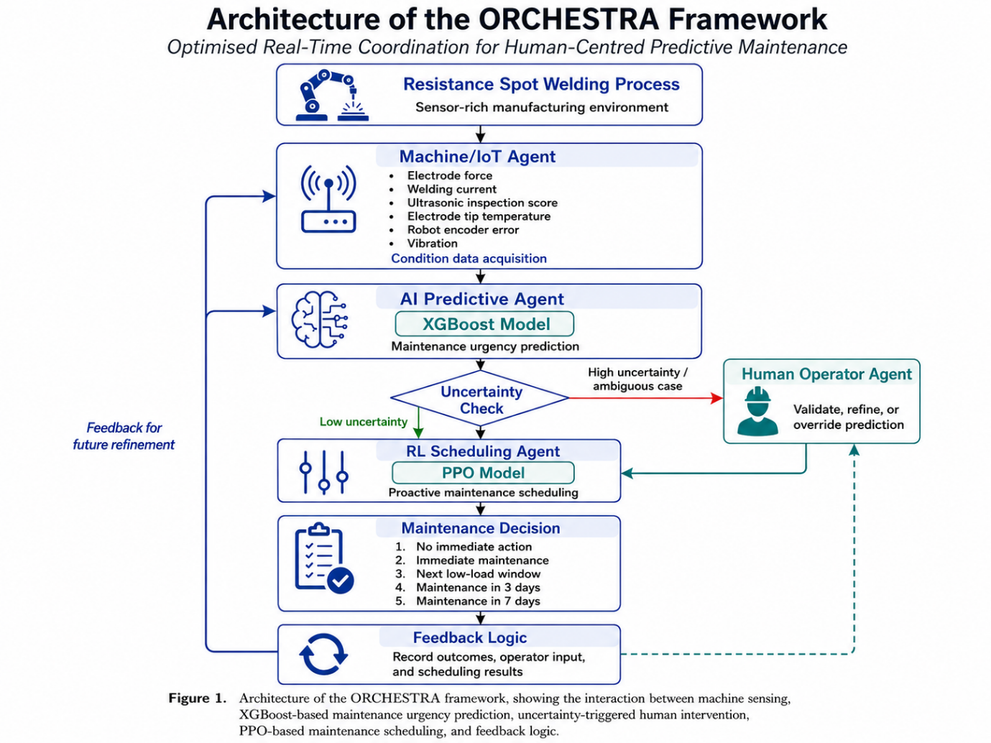
Figure 1. Architecture of the ORCHESTRA framework, showing the interaction between machine sensing, XGBoost-based maintenance urgency prediction, uncertainty-triggered human intervention, PPO-based maintenance scheduling, and feedback logic.

3.2 Agent Roles
The ORCHESTRA framework is structured around the principle that predictive maintenance requires different forms of intelligence. The Machine/IoT Agent provides data-based awareness of the physical welding process. The AI Predictive Agent transforms sensor data into a maintenance urgency estimate. The Human Operator Agent contributes contextual judgement when the system detects uncertainty or operational ambiguity. The Reinforcement Learning Scheduling Agent converts the predictive and contextual information into a maintenance action.
This separation of responsibilities is important because predictive maintenance decisions are not all of the same type. Some decisions are data-driven, such as estimating degradation from process variables. Others are operational, such as deciding whether maintenance should be performed immediately or delayed due to production constraints. Other decisions require human judgement, particularly when the sensor data does not fully capture the real condition of the process.
Table 1. Agent roles in the ORCHESTRA framework
Agent | Main role | Input | Output
Machine/IoT Agent | Collects and transfers process condition data from the resistance spot welding system | Sensor readings from the welding process | Pre-processed process condition data
AI Predictive Agent | Estimates maintenance urgency using XGBoost | Process condition data | Maintenance urgency score, severity level, and uncertainty indication
Human Operator Agent | Reviews uncertain predictions and provides contextual judgement | AI prediction, uncertainty level, operational context, and explainability information | Validation, refinement, or override
RL Scheduling Agent | Selects proactive maintenance action using PPO | Severity, uncertainty, resource availability, production load, cost factor, and human input when available | Maintenance scheduling decision
Feedback Logic | Records decisions and outcomes for future improvement | Maintenance outcomes, overrides, scheduling results, cost, downtime, and failure state | Updated decision information for later cycles
The use of multiple agents allows ORCHESTRA to coordinate technical and human-centred decision-making. Rather than allowing a single model to determine the full maintenance response, the framework distributes responsibility across agents. This helps make the system more interpretable, more adaptable, and more suitable for future industrial deployment.

3.3 Machine/IoT Agent
The Machine/IoT Agent represents the resistance spot welding process within the ORCHESTRA framework. Its role is to collect, organise, and transfer sensor-based information that describes the condition of the welding operation. In a physical implementation, this agent would be connected to industrial sensors, programmable logic controllers, robot controllers, or industrial communication protocols. In the present simulation-based proof-of-concept, the agent represents the data acquisition layer using process variables associated with resistance spot welding condition monitoring.
The process variables considered in the framework include electrode force, welding current, ultrasonic inspection score, electrode tip temperature, robot encoder error, and vibration. These variables were selected because they represent different aspects of welding process stability and possible degradation. For example, changes in electrode force may indicate contact inconsistency or mechanical degradation. Variations in welding current may affect heat generation and weld quality. Increased electrode tip temperature may suggest thermal stress, heat accumulation, or electrode wear. Robot encoder error may indicate positioning inaccuracies, while vibration can provide information about mechanical irregularity or process disturbance. These variables are already identified in Draft 3 as the core sensing variables used by the Machine/IoT Agent.
The Machine/IoT Agent does not make maintenance decisions directly. Its purpose is to provide condition awareness for the wider decision-making system. Without reliable process data, the AI Predictive Agent cannot estimate maintenance urgency, and the RL Scheduling Agent cannot select meaningful maintenance actions. Therefore, this agent acts as the foundation of the ORCHESTRA architecture.
In the proposed workflow, the Machine/IoT Agent performs three main functions. First, it receives or represents process condition data from the resistance spot welding system. Second, it organises the data into a structured feature vector suitable for prediction. Third, it transfers the processed condition data to the AI Predictive Agent for maintenance urgency estimation.

3.4 AI Predictive Agent
The AI Predictive Agent is responsible for estimating maintenance urgency from the condition data supplied by the Machine/IoT Agent. In ORCHESTRA, this agent uses an XGBoost-based model to predict a maintenance urgency score from the selected resistance spot welding variables. XGBoost is used because it is suitable for structured tabular data, can model non-linear relationships, and provides a strong balance between predictive performance and computational efficiency.
The role of the AI Predictive Agent is not simply to classify the system as healthy or faulty. Instead, it provides a continuous or severity-based indication of maintenance urgency. This is important because maintenance decisions in production environments are rarely binary. A system may show early signs of degradation without requiring immediate shutdown, or it may show a high-risk condition that requires rapid intervention. By estimating maintenance urgency, the AI Predictive Agent provides the scheduling layer with a more flexible basis for decision-making.
The output of the AI Predictive Agent includes the predicted maintenance urgency score, a derived severity level, and an uncertainty indication. This information is passed to the Human Operator Agent and the RL Scheduling Agent. When the prediction is clear and confidence is high, the system can proceed towards scheduling with minimal human involvement. When the prediction is uncertain, ambiguous, or operationally sensitive, the Human Operator Agent is activated to review the decision context. Draft 3 already establishes this logic, where uncertain predictions activate the Human Operator Agent before scheduling decisions are finalised.
This design avoids treating the predictive model as an unquestioned authority. Instead, the AI Predictive Agent is one component within a wider decision architecture. Its prediction informs the maintenance process, but the final decision can be refined through human judgement and translated into action through reinforcement learning-based scheduling.

3.5 Human Operator Agent
The Human Operator Agent is a central element of ORCHESTRA. Its inclusion reflects the principle that human expertise remains valuable in smart manufacturing, particularly when automated systems encounter uncertainty, incomplete information, or operationally sensitive conditions. In resistance spot welding environments, operators may observe signs that are not fully captured by sensors, such as abnormal sound, visible electrode wear, unexpected process behaviour, recent production changes, machine history, or practical maintenance constraints.
In ORCHESTRA, the human operator is not treated as a passive supervisor who only receives system alerts. Instead, the operator is represented as an active agent who can validate, refine, or override the AI Predictive Agent’s recommendation when specific conditions are met. This is important because involving the human in every decision would increase workload and reduce system efficiency. Therefore, ORCHESTRA uses a selective human-in-the-loop mechanism.
Human intervention is triggered when the system identifies uncertainty, ambiguity, or operational conflict. This may occur when the predicted maintenance urgency lies within a medium-risk band, when uncertainty exceeds a defined threshold, when sensor indicators produce conflicting signals, or when the predicted maintenance action may significantly affect production. When triggered, the Human Operator Agent reviews the AI recommendation and provides contextual input. This input may confirm the model output, adjust the severity level, or influence the scheduling decision.
To make the human review process more practical, the Human Operator Agent should receive not only the predicted urgency score, but also supporting decision information. This may include the uncertainty level, the dominant sensor variables influencing the prediction, the reason why human review was triggered, and the suggested scheduling action. This strengthens ORCHESTRA by making the human intervention stage more explainable and operationally meaningful.
Table 2. Selective human review logic in ORCHESTRA
Decision condition | System action | Human role
Low urgency and low uncertainty | Automatic scheduling | No review required
Medium urgency and high uncertainty | Human review triggered | Validate or refine prediction
High urgency and high confidence | Direct scheduling or limited review | Confirm critical decision if required
High urgency and low resource availability | Human review triggered | Assess operational feasibility
Conflicting sensor patterns | Human review triggered | Provide contextual judgement
Operationally sensitive maintenance timing | Human review triggered | Refine scheduling decision
The purpose of this mechanism is not to replace the AI model with human judgement. Instead, it combines both forms of intelligence. The AI model provides consistency and computational speed, while the human operator provides experience, context, and practical awareness. This creates a balanced decision process in which predictive maintenance is both data-driven and operationally grounded.

3.6 Reinforcement Learning Scheduling Agent
The Reinforcement Learning Scheduling Agent is responsible for converting predictive and contextual information into a proactive maintenance decision. In ORCHESTRA, this agent uses Proximal Policy Optimisation to select maintenance actions within a simulated resistance spot welding maintenance environment. Within the ORCHESTRA framework, the RL Scheduling Agent as the component that converts predicted severity, uncertainty, resource availability, production load, cost, and human input into a maintenance decision.
The scheduling problem is formulated as a sequential decision-making task. At each decision step, the RL Scheduling Agent observes the current system state and selects an action that aims to reduce maintenance risk while controlling downtime and cost. The state includes estimated time-to-failure, predicted severity, resource availability, production load, time since last maintenance, maintenance cost factor, and uncertainty level. Where the Human Operator Agent is activated, the refined prediction or override is also passed to the scheduling process.
The action space consists of five possible maintenance decisions.
Table 3. Maintenance actions used by the RL Scheduling Agent
Action | Maintenance decision
0 | Take no immediate action
1 | Schedule immediate maintenance
2 | Schedule maintenance during the next low-load production window
3 | Schedule maintenance in three days
4 | Schedule maintenance in seven days
This structure reflects the practical nature of industrial maintenance. Not every predicted risk requires immediate shutdown, and not every maintenance action can be delayed without consequence. The RL Scheduling Agent therefore learns to balance competing objectives, including risk reduction, downtime minimisation, maintenance cost control, production disruption, and the reliability of the prediction.
The novelty of this layer does not come from modifying the PPO algorithm itself. Instead, the contribution lies in the context-aware formulation of the scheduling problem. PPO is used within a maintenance-specific environment where scheduling decisions are guided by technical risk, operational constraints, and selective human input. This allows the framework to move beyond simple threshold-based maintenance alerts and towards adaptive maintenance scheduling.

3.7 Communication and Feedback Logic
The effectiveness of ORCHESTRA depends on the communication logic between agents. The framework is designed around a structured flow of information, where sensor data, predictions, human input, scheduling decisions, and outcomes are shared across the system. This is important because predictive maintenance is not a one-way process from data to action. Each maintenance decision produces new information that can be used to improve future prediction, scheduling, and human intervention logic.
The communication process begins with the Machine/IoT Agent, which provides sensor-based condition data from the resistance spot welding process. The AI Predictive Agent processes this data and generates a maintenance urgency prediction. The uncertainty mechanism then determines whether human review is required. If the prediction is stable and confidence is high, the information can be passed directly to the RL Scheduling Agent. If the prediction is uncertain, ambiguous, or operationally sensitive, the Human Operator Agent is activated to provide contextual input.
Once the prediction and any human refinement have been finalised, the RL Scheduling Agent selects a maintenance action. This action may involve immediate intervention, delayed intervention, scheduling during a low-load window, or no immediate maintenance. The selected action and its outcome are then recorded through the feedback logic. In a future physical implementation, this feedback could include whether the maintenance action prevented failure, whether downtime was reduced, whether the operator override was useful, and whether the scheduling decision aligned with production requirements.
Table 4. Proposed communication protocol between ORCHESTRA agents
Message | Sender | Receiver | Content
Condition message | Machine/IoT Agent | AI Predictive Agent | Sensor vector, timestamp, process state
Prediction message | AI Predictive Agent | Human Operator Agent / RL Scheduling Agent | Urgency score, severity level, uncertainty level
Review message | Human Operator Agent | RL Scheduling Agent | Validation, refinement, override, contextual note
Scheduling message | RL Scheduling Agent | Maintenance system / feedback logic | Selected action, timing, decision confidence
Feedback message | Maintenance system / feedback logic | All agents | Outcome, downtime proxy, cost proxy, failure state, intervention result
The general communication sequence is as follows:
- The Machine/IoT Agent collects resistance spot welding condition data.
- The AI Predictive Agent estimates maintenance urgency using XGBoost.
- The uncertainty mechanism determines whether human review is required.
- The Human Operator Agent validates, refines, or overrides the prediction when triggered.
- The RL Scheduling Agent selects a proactive maintenance action using PPO.
- The selected decision and outcome are recorded.
- The feedback loop supports future refinement of prediction, scheduling, and human intervention logic.
This communication structure positions ORCHESTRA as a coordinated human-AI maintenance framework rather than a standalone predictive model. The framework is designed to support more context-aware, transparent, and adaptive maintenance decision-making in smart manufacturing environments.

3.8 Summary of the Framework
ORCHESTRA provides a structured architecture for connecting machine sensing, AI prediction, human judgement, and reinforcement learning-based scheduling in predictive maintenance. Its main value is not limited to the use of XGBoost or PPO. Instead, its contribution lies in the way these components are coordinated within a human-centred multi-agent decision process.
The Machine/IoT Agent provides condition awareness. The AI Predictive Agent estimates maintenance urgency. The Human Operator Agent reviews uncertain or sensitive cases. The RL Scheduling Agent converts the available information into a maintenance action. The feedback logic then records outcomes for future refinement. Together, these components allow ORCHESTRA to transform predictive maintenance from a model-centred prediction task into a coordinated decision-support framework for resistance spot welding.
This section establishes the architecture of ORCHESTRA. The following section describes the methodology used to implement and evaluate the framework through a simulation-based proof-of-concept.

4. Methodology

4.1 Simulation-Based Research Design
This study adopts a simulation-based research design to evaluate the feasibility of the proposed ORCHESTRA framework before implementation in a physical resistance spot welding environment. Simulation is appropriate at this stage because the proposed framework integrates multiple decision-making components, including machine condition monitoring, maintenance urgency prediction, human review, and reinforcement learning-based scheduling. Testing these components directly in an industrial production line would require live machine access, operator participation, maintenance records, and controlled failure or degradation scenarios, which may not be practical during the early development stage.
The simulation-based approach allows the framework to be evaluated under controlled and repeatable conditions. It enables the interaction between the Machine/IoT Agent, AI Predictive Agent, Human Operator Agent, and RL Scheduling Agent to be tested without disrupting production activities or introducing risk to real equipment. This is particularly important for predictive maintenance research, where failure events may be rare, costly, or difficult to reproduce in a controlled industrial setting.
The methodology follows a sequential development and evaluation pipeline composed of six main stages: system modelling and agent definition, data integration and pre-processing, maintenance urgency prediction, human collaboration simulation, proactive maintenance scheduling, and validation and analysis. First, the ORCHESTRA framework is defined by establishing the agent roles and mapping their interactions. Second, the resistance spot welding data are prepared, cleaned, filtered, and normalised for model development. Third, multiple predictive models are compared, with XGBoost selected to estimate maintenance urgency. Fourth, the human collaboration simulation evaluates uncertainty and triggers operator review when required, allowing the decision to be validated or refined. Fifth, a PPO-based scheduling environment is developed to optimise maintenance timing and generate maintenance actions. Finally, the framework is evaluated through prediction assessment, scheduling analysis, and sensitivity testing. This pipeline allows each component of ORCHESTRA to be developed systematically while also assessing the performance of the integrated human-centred predictive maintenance architecture.
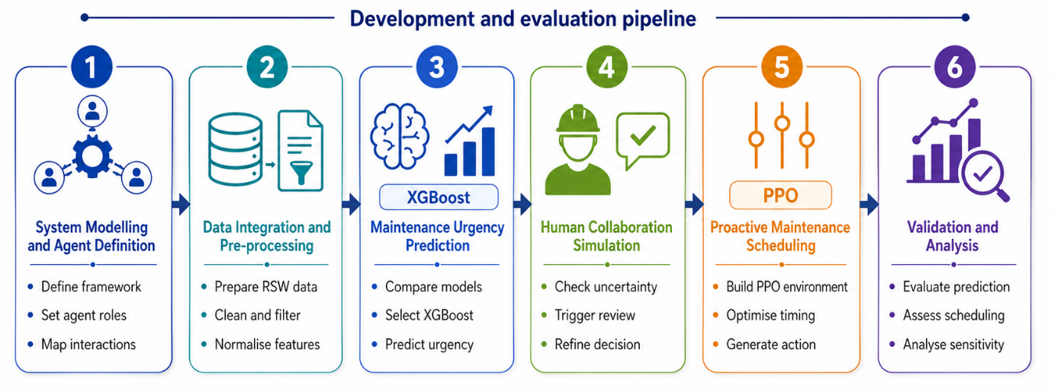
Figure X. Development and evaluation pipeline of the ORCHESTRA framework, showing the six methodological stages
Python-based tools were used for the implementation. Machine learning experiments were conducted using standard data science libraries, while the reinforcement learning environment was implemented using Gymnasium and Stable-Baselines3. The simulation-based workflow was designed to provide a proof-of-concept for the proposed framework and to establish a foundation for future validation using live resistance spot welding data and real operator interaction.

4.2 Resistance Spot Welding Case Study
Resistance spot welding was selected as the target manufacturing process because of its industrial relevance, particularly in automotive production [Reference]. The process is widely used for joining sheet metal components because it is fast, repeatable, and suitable for high-volume manufacturing. However, the process is also sensitive to changes in machine condition, electrode behaviour, thermal effects, positioning accuracy, and process stability. These characteristics make resistance spot welding a suitable case study for predictive maintenance research.
In resistance spot welding, weld quality and process reliability can be affected by changes in electrode force, welding current, electrode tip temperature, ultrasonic inspection response, robot encoder error, and vibration. For example, electrode degradation can alter contact conditions and heat generation, while increased vibration or robot encoder error may indicate mechanical instability or positioning inaccuracies. These changes may not immediately cause process failure, but they can gradually reduce weld consistency and increase the risk of defects, rework, or downtime.
In the proposed simulation, the resistance spot welding process is represented by the Machine/IoT Agent. This agent provides condition-monitoring data to the AI Predictive Agent, which estimates maintenance urgency. The resulting prediction, together with uncertainty and operational context, is then used by the Human Operator Agent and the RL Scheduling Agent to support proactive maintenance decision-making.
The case study is therefore used to demonstrate the feasibility of ORCHESTRA as a human-centred predictive maintenance framework. It does not claim to represent a complete live industrial deployment at this stage. Instead, it provides a controlled proof-of-concept for connecting machine sensing, XGBoost-based prediction, uncertainty-triggered human intervention, PPO-based scheduling, and feedback logic.

4.3 Dataset Description
The dataset used in this study was obtained from the public dataset “Resistance Spot Welding Insights: A Dataset Integrating Process Parameters, Infrared, and Surface Imaging”, published by Dominguez Molina through Mendeley Data and also available through Kaggle. The dataset provides a comprehensive record of the resistance spot welding process, including monitored process parameters such as current and force during nugget formation, input parameters such as welding time, applied electrode force, material thickness, and material type, as well as welding outputs such as mechanical resistance, nugget diameter, and corresponding classifications. The dataset also includes thermographic and digital images of the welding nugget, which provide additional information about the relationship between process parameters and weld formation.
In this study, the dataset is treated as a public resistance spot welding dataset adapted for the simulation-based evaluation of the ORCHESTRA framework. The original dataset was not collected from a live deployment of the proposed framework. Instead, it was used to represent resistance spot welding sensor and process behaviour under controlled experimental conditions. Therefore, the results should be interpreted as proof-of-concept evidence for the proposed human-centred predictive maintenance architecture, rather than as direct validation in an industrial production line.
For the ORCHESTRA simulation, the dataset was used to construct a condition-monitoring representation of the resistance spot welding process. The selected variables were used to represent process condition, degradation indicators, and maintenance-relevant behaviour. These variables support the AI Predictive Agent in estimating maintenance urgency and provide input for the uncertainty-triggered human review mechanism and PPO-based scheduling environment.
The input variables considered in the simulation include electrode force, welding current, ultrasonic inspection score, electrode tip temperature, robot encoder error, and vibration. The target variable used in this study was the Predictive_Maintenance_Score, which represents maintenance urgency as a continuous score from 0 to 100. This continuous target was selected because the ORCHESTRA framework requires a graded estimate of maintenance urgency rather than only a discrete health category. Where required, variables not directly available in the original dataset were derived, adapted, or simulated to support the maintenance scheduling environment. This was necessary because the original dataset focuses on resistance spot welding process parameters, imaging, and weld quality outputs, whereas ORCHESTRA evaluates a wider predictive maintenance decision-making pipeline.
Table 2. Dataset variables used in the ORCHESTRA simulation
Feature / Target | Description | Role in the framework
Electrode_Force_N | Applied electrode force in newtons | Input feature
Welding_Current_kA | Electrical welding current in kiloamperes | Input feature
Ultrasonic_Inspection_Score | Weld integrity or inspection-related indicator | Input feature
Electrode_Tip_Temp_C | Electrode or welding temperature-related indicator | Input feature
Robot_Encoder_Error_mm | Simulated robot positional deviation | Input feature
Vibration_Sensor_RMS_ms2 | Simulated vibration-related condition indicator | Input feature
Predictive_Maintenance_Score | Derived maintenance urgency score | Target variable
Because the original dataset was not specifically designed for predictive maintenance scheduling, the present study uses it as a foundation for a simulation-based maintenance scenario. The dataset supports the resistance spot welding context, while additional derived or simulated variables allow the ORCHESTRA framework to evaluate maintenance urgency prediction, uncertainty-triggered human intervention, and PPO-based scheduling. Future work should validate the framework using live industrial resistance spot welding data with directly measured degradation, maintenance events, operator decisions, and production constraints.

4.4 Data Pre-Processing
The dataset was pre-processed before model training and simulation. The purpose of this stage was to improve data consistency, reduce the influence of abnormal values, and prepare the input variables for both the machine learning and reinforcement learning components.
The pre-processing procedure was designed to ensure that the resistance spot welding variables were suitable for machine learning model training and reinforcement learning simulation. The dataset was first inspected for missing or incomplete values. Where missing values were identified, median imputation was applied rather than mean imputation, as the median is less sensitive to extreme values and is therefore more appropriate for process data that may contain abnormal readings.
Outliers were then examined using the interquartile range method. Values falling outside the acceptable range were clipped rather than removed, because removing complete samples could reduce the representativeness of the welding process conditions. This approach allowed extreme values to be controlled while preserving the size and continuity of the dataset. Signal variation was also reduced using a moving-average filter where required, as sensor-based manufacturing data may contain short-term fluctuations that do not necessarily represent meaningful process degradation.
Finally, all numerical features were normalised to a common scale before model training and scheduling simulation. This was necessary because the input variables used different units and magnitudes, such as force, current, temperature, positional error, and vibration. Normalisation prevented variables with larger numerical ranges from disproportionately influencing the learning process and supported more stable behaviour across the XGBoost prediction model and PPO scheduling environment.
The processed dataset was then prepared for model development and testing. The final predictive model was selected through a comparative evaluation of 18 machine learning algorithms, as described in Section 4.5 and reported in Section 5.1. Following this comparison, XGBoost was selected as the AI Predictive Agent. The dataset was divided using an 80:20 train-test split, with 80% used for model training and 20% held out for testing. The processed outputs were also used to derive severity and uncertainty values for integration into the PPO scheduling environment.

4.5 XGBoost Model Training for Maintenance Urgency Prediction
The AI Predictive Agent was implemented using an XGBoost-based model to estimate maintenance urgency from the resistance spot welding condition variables. The purpose of this agent was to transform the pre-processed process data into a predictive maintenance output that could be used by the uncertainty-triggered human review mechanism and the PPO-based scheduling environment.
XGBoost was not selected a priori. Before defining the final AI Predictive Agent, a comparative model selection stage was conducted using 18 machine learning algorithms across different model families. These included baseline models, instance-based methods, tree-based models, kernel-based methods, bagging ensembles, boosting ensembles, and neural network models. The comparison was included to identify the most suitable model for the resistance spot welding dataset, rather than assuming that one algorithm would be appropriate for all predictive maintenance contexts.
The models were evaluated using five-fold cross-validation on the pre-processed dataset. The selection criteria included predictive performance, error level, stability across folds, and computational time. These criteria were selected because the predictive model needed to be accurate enough to estimate maintenance urgency, stable enough to support consistent decision-making, and computationally efficient enough to be integrated within a wider maintenance decision-support framework.
The model comparison showed that several boosting-based and neural network models achieved strong predictive performance. Although the simple MLP model achieved a slightly higher mean accuracy, XGBoost provided the strongest overall balance between predictive performance, mean absolute error, stability, and computational time. In particular, XGBoost achieved high mean accuracy while requiring substantially less computational time than Gradient Boosting and the simple MLP model. This balance made XGBoost the most appropriate choice for the AI Predictive Agent within ORCHESTRA. Your current results show this clearly: the MLP simple network achieved 93.69% mean accuracy with a mean cross-validation time of 26.91 s and MAE of 1.92, while XGBoost achieved 93.62% mean accuracy with a shorter mean cross-validation time of 5.07 s and lower MAE of 1.68.
After model selection, the final XGBoost model was trained using an 80:20 train-test split. The six resistance spot welding condition variables were used as input features: electrode force, welding current, ultrasonic inspection score, electrode tip temperature, robot encoder error, and vibration. The target variable was the predictive maintenance score, which represents the maintenance urgency level used by the ORCHESTRA framework.
The final XGBoost model was configured as a regression model because the objective was to estimate a continuous maintenance urgency score rather than only classify the process into discrete health categories. The key hyperparameters used for the XGBoost regressor are summarised in Table 3.
Table 3. XGBoost hyperparameters used for maintenance urgency prediction
Parameter | Value | Description
Objective | reg:squarederror | Regression objective used for continuous urgency prediction
N_estimators | 500 | Number of boosting rounds
Learning_rate | 0.05 | Step size shrinkage used to control learning progression
Max_depth | 6 | Maximum tree depth
Subsample | 0.8 | Subsample ratio of training instances
Colsample_bytree | 0.8 | Subsample ratio of columns used in each tree
Random_state | 42 | Reproducibility setting
The output of the XGBoost model was used in three ways within ORCHESTRA. First, it provided the maintenance urgency score used to represent the predicted condition of the resistance spot welding process. Second, the urgency score was converted into severity bands for the human review mechanism. Third, the prediction output was incorporated into the PPO scheduling environment as part of the system state. In this way, the XGBoost model acted as the predictive layer that connected process condition monitoring with human-centred decision support and proactive maintenance scheduling.

4.6 Uncertainty Estimation and Human Review Rules
The Human Operator Agent was implemented through an uncertainty-triggered review mechanism. The purpose of this mechanism was to represent how human contextual judgement can be introduced into predictive maintenance decisions without requiring human involvement in every case.
The system evaluates the prediction generated by the AI Predictive Agent and determines whether human review is required. Human review is triggered when the predicted maintenance condition is uncertain, ambiguous, or operationally sensitive. In the proposed framework, uncertainty can arise from medium-severity predictions, high uncertainty values, conflicting condition indicators, or cases where the predicted maintenance action may create a conflict with production constraints.
The predicted maintenance urgency score is divided into three severity bands: low, medium, and high. Low-severity cases indicate limited maintenance urgency and are normally passed directly to the scheduling agent. Medium-severity cases are treated as ambiguous and normally trigger human review. High-severity cases may proceed directly to urgent scheduling when confidence is high, but may still trigger review if operational constraints or conflicting indicators are present.
Table 4. Human review rules used in ORCHESTRA
Condition | Human review? | Output
Low severity and low uncertainty | No | Direct to PPO scheduling
Medium severity | Yes | Validate or refine prediction
High uncertainty | Yes | Validate or refine prediction
High severity and high confidence | Optional or no | Direct urgent scheduling
Conflicting indicators | Yes | Override possible
High severity and low resource availability | Yes | Contextual scheduling refinement
The human review process has three possible outcomes. First, the operator may validate the AI prediction and allow it to proceed without change. Second, the operator may refine the prediction by adjusting the severity level or adding contextual information. Third, the operator may override the prediction when the sensor-based output does not reflect the perceived condition of the process. The resulting validated, refined, or overridden decision is then passed to the RL Scheduling Agent.
This selective mechanism is designed to balance automation and human judgement. It reduces unnecessary operator workload by avoiding review in low-risk and high-confidence cases, while preserving human involvement in cases where contextual knowledge is most valuable.

4.7 PPO-Based Maintenance Scheduling Environment
The RL Scheduling Agent was implemented using Proximal Policy Optimisation within a custom Gymnasium environment. The purpose of this environment was to simulate proactive maintenance scheduling for a single-machine resistance spot welding system.
The scheduling problem was formulated as a sequential decision-making task. At each decision step, the PPO agent observes the current system state and selects a maintenance action. The state representation includes seven normalised continuous variables: estimated time-to-failure, predicted severity, resource availability, production load, time since last maintenance, maintenance cost factor, and uncertainty level. When human review is triggered, the validated or refined human input is incorporated into the scheduling state.
The action space consists of five discrete maintenance decisions: no immediate action, immediate maintenance, maintenance during the next low-load production window, maintenance in three days, and maintenance in seven days. This action structure reflects the practical reality of industrial maintenance, where not all degradation signals require immediate shutdown and not all interventions can be delayed without increasing risk.
Table 5. PPO scheduling environment
Component | Description
Environment type | Custom Gymnasium environment for single-machine proactive maintenance
Episode length | 100 steps
State space | Seven normalised continuous features
Action space | Five discrete maintenance scheduling actions
Reward design | Context-aware reward balancing risk, downtime, cost, production disruption, and unnecessary maintenance
Termination | End of episode or critical failure
Human collaboration | Triggered in uncertain or operationally sensitive cases
Table 6. Maintenance actions used by the PPO agent
Action | Maintenance scheduling decision
0 | Take no immediate action
1 | Schedule immediate maintenance
2 | Schedule maintenance during the next low-load production window
3 | Schedule maintenance in three days
4 | Schedule maintenance in seven days
The PPO scheduling environment was not designed to optimise maintenance decisions in isolation. Instead, it was integrated into the wider ORCHESTRA architecture, where scheduling decisions are informed by XGBoost-based urgency prediction and, where required, human contextual input.

4.8 Context-Aware Reward Function
The reward function was designed to guide the PPO agent towards maintenance decisions that reduce failure risk while avoiding unnecessary maintenance, excessive downtime, high cost, and disruption during high production load. This reward design is important because the novelty of the scheduling layer does not lie in modifying PPO itself, but in formulating a context-aware maintenance scheduling environment aligned with the ORCHESTRA decision process.
The reward function penalises critical failure, delayed maintenance under high-risk conditions, unnecessary maintenance under low-risk conditions, excessive downtime, high maintenance cost, and disruptive maintenance during high production load. It rewards timely intervention when the predicted risk is high and efficient deferral when the machine condition is stable.
A simplified reward formulation is expressed as:
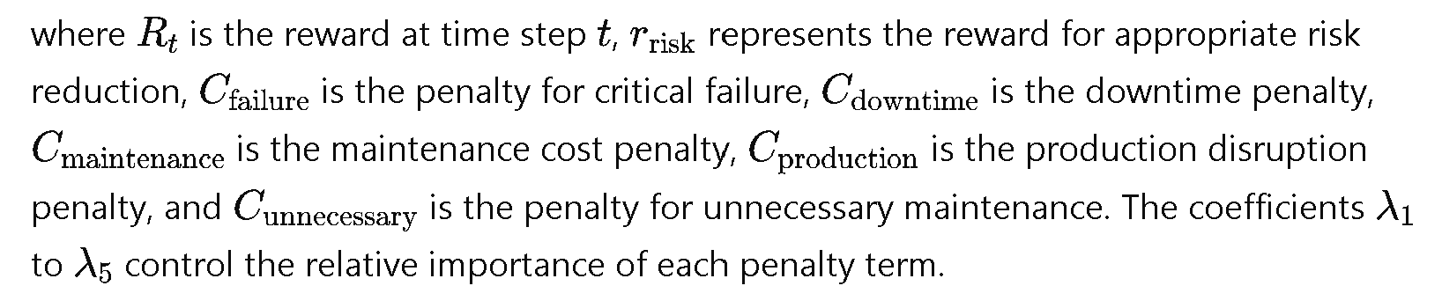
The reward logic can also be summarised as follows:
If critical failure occurs:
apply large failure penalty
If high severity and early maintenance is selected:
reward timely intervention
If high severity and maintenance is delayed:
apply risk penalty
If low severity and immediate maintenance is selected:
apply unnecessary maintenance penalty
If production load is high and non-critical maintenance is selected:
apply production disruption penalty
If maintenance cost is high:
apply cost penalty proportional to action intensity
If low-load window scheduling is selected under moderate risk:
reward balanced maintenance timing
This context-aware reward formulation enables the PPO agent to learn maintenance decisions that consider both technical risk and operational feasibility. It also supports the wider human-centred purpose of ORCHESTRA, where automated scheduling is guided by prediction, uncertainty, and contextual information.
4.9 PPO Training and Evaluation
The PPO agent was trained using Stable-Baselines3 with a multi-layer perceptron policy network. The policy network used two hidden layers of 64 units with tanh activation functions. Training was conducted over 200,000 timesteps to support policy convergence within the multi-objective scheduling environment.
The key PPO hyperparameters included a learning rate of 3×10⁻⁴ , batch size of 64, clip range of 0.2, entropy coefficient of 0.01, and discount factor of 0.99. The model also used 2048 steps per update and generalised advantage estimation with λ=0.95.
The trained policy was evaluated using deterministic testing across multiple simulation episodes. Deterministic evaluation was used to reduce the influence of exploration noise and provide a more stable assessment of scheduling behaviour. The evaluation examined whether the PPO agent selected appropriate maintenance actions under different combinations of predicted severity, uncertainty, production load, resource availability, and cost factor.
The PPO agent was evaluated both as part of the full ORCHESTRA framework and in comparison with baseline and ablation configurations. This allowed the study to examine the contribution of the scheduling layer within the wider architecture.

4.10 Baseline Comparison Design
To evaluate the added value of the ORCHESTRA framework, the full architecture was compared against a set of baseline maintenance decision strategies. These baselines represent common maintenance and scheduling approaches with different levels of automation, prediction, and human involvement.
The reactive maintenance baseline represents traditional failure-based maintenance, where intervention occurs only after a critical condition is reached. The fixed preventive maintenance baseline represents time-based maintenance, where intervention occurs at fixed intervals regardless of machine condition. The XGBoost-only alert strategy evaluates the value of prediction without adaptive scheduling. The rule-based scheduling strategy uses fixed thresholds to select maintenance actions. The PPO-only scheduling strategy evaluates adaptive scheduling without human review. The full ORCHESTRA framework combines XGBoost-based urgency prediction, uncertainty-triggered human review, and PPO-based scheduling.
Table 7. Baseline comparison design
Strategy | Prediction | Human review | Scheduling logic | Purpose
Reactive maintenance | No | No | Act after failure | Traditional failure-based maintenance
Fixed preventive maintenance | No | No | Fixed interval | Time-based maintenance
XGBoost-only alert strategy | Yes | No | Threshold alert | Prediction without scheduling intelligence
Rule-based scheduling | Yes | No/limited | Fixed thresholds | Deterministic decision logic
PPO-only scheduling | Yes | No | PPO scheduling | Fully automated adaptive scheduling
Full ORCHESTRA | Yes | Yes | PPO scheduling with human review | Proposed framework
The comparison was designed to examine whether the full ORCHESTRA architecture provides advantages over simpler strategies in terms of critical failures, downtime proxy, cost proxy, unnecessary maintenance, action distribution, and human intervention rate.

4.11 Ablation Study Design
An ablation study was designed to examine the contribution of each major component within the ORCHESTRA framework. This is important because the framework combines several elements, including predictive modelling, human review, and reinforcement learning-based scheduling. The ablation study allows the effect of each component to be assessed separately and in combination.
Four configurations were considered. Version A includes only the XGBoost predictive model. Version B combines XGBoost with PPO scheduling. Version C combines XGBoost with human review but does not include PPO scheduling. Version D represents the full ORCHESTRA framework, combining XGBoost, human review, and PPO scheduling.
Table 8. Ablation study configurations
Version | Components included | Purpose
A | XGBoost only | Evaluates prediction without scheduling or human review
B | XGBoost + PPO | Evaluates adaptive scheduling without human review
C | XGBoost + Human Review | Evaluates human contextual refinement without PPO scheduling
D | XGBoost + Human Review + PPO | Evaluates the full ORCHESTRA architecture
This ablation design helps demonstrate whether the full framework provides added value beyond the individual use of prediction, human intervention, or scheduling alone. It also supports the argument that the main contribution of ORCHESTRA lies in the coordination of these components within a unified architecture.

4.12 Sensitivity Analysis Design
A sensitivity analysis was designed to examine the robustness of the ORCHESTRA framework under different simulation conditions. The analysis focuses on four areas: uncertainty threshold, noise level, reward weights, and human intervention frequency.
The uncertainty threshold analysis evaluates how different levels of human review affect the performance of the system. A lower uncertainty threshold increases human involvement, which may reduce risky decisions but increase operator workload. A higher uncertainty threshold reduces human involvement, improving automation but potentially allowing more uncertain cases to proceed without contextual validation.
The noise sensitivity analysis evaluates how the predictive and scheduling components respond to changes in data quality. This is important because live industrial data may contain noise, sensor drift, missing values, and unexpected process variation.
The reward weight sensitivity analysis evaluates whether changes in the relative importance of risk, downtime, cost, and production disruption affect the scheduling policy. This helps determine whether the PPO agent remains stable under different maintenance priorities.
Finally, the human intervention frequency analysis examines the trade-off between automation and human workload. This supports the human-centred argument of the framework by evaluating whether selective review can provide a practical balance between operator involvement and automated decision-making.
Table 9. Sensitivity analysis design
Sensitivity factor | Tested variation | Purpose
Uncertainty threshold | Low, medium, high threshold | Examine automation-human balance
Noise level | Low, medium, high noise | Test robustness under data quality variation
Reward weights | Risk-focused, cost-focused, balanced | Evaluate scheduling policy stability
Human intervention frequency | Low, moderate, high review rate | Examine workload and decision reliability

4.13 Evaluation Metrics
The ORCHESTRA framework was evaluated using metrics associated with prediction performance, scheduling performance, human-AI coordination, baseline comparison, and ablation analysis. These metrics were selected to assess both the performance of individual components and the added value of the full architecture.
Prediction performance was evaluated using mean squared error, mean absolute error, and coefficient of determination. These metrics assess the accuracy of the XGBoost maintenance urgency prediction model.
Scheduling performance was evaluated using mean episode reward, critical failure occurrence, action distribution, downtime proxy, cost proxy, and unnecessary maintenance actions. These metrics assess whether the PPO agent selects appropriate maintenance actions under different operational conditions.
Human-AI coordination was evaluated using human intervention rate, number of overrides, decision changes after human input, and the automation-human balance. These metrics assess whether the human review mechanism supports contextual refinement without excessive operator workload.
Baseline and ablation performance were evaluated by comparing the full ORCHESTRA framework against simpler strategies and reduced framework configurations. The comparison considered the performance difference between strategies, improvement over baselines, and the contribution of each component.
Table 10. Evaluation metrics used in the ORCHESTRA methodology
Evaluation category | Metrics
Prediction metrics | MSE, MAE, R²
Scheduling metrics | Mean episode reward, critical failures, action distribution, downtime proxy, cost proxy, unnecessary maintenance actions
Human-AI metrics | Human intervention rate, number of overrides, decision changes after human input, automation-human balance
Baseline comparison metrics | Performance difference between strategies, improvement over baselines
Ablation metrics | Contribution of prediction, human review, and PPO scheduling
Robustness metrics | Sensitivity to uncertainty threshold, noise level, reward weights, and intervention frequency

4.14 Reproducibility and Computational Setting
The experiments were designed with reproducibility in mind. The implementation used Python-based tools for data handling, machine learning, reinforcement learning, and visualisation. The workflow included data pre-processing, model comparison, XGBoost training, PPO environment development, baseline comparison, ablation analysis, and sensitivity testing.
A fixed random seed was used where applicable to support repeatability. The machine learning model comparison used cross-validation, while the final XGBoost model was evaluated using a held-out test set. The PPO agent was trained and evaluated across multiple simulation episodes to examine scheduling behaviour under changing maintenance conditions.
The computational setting used standard computing hardware, making the proof-of-concept suitable for replication without specialist industrial infrastructure. The complete implementation should include the processed dataset structure, model configuration, PPO environment definition, training parameters, evaluation scripts, and simulation logs. A public repository will be included in the final version to support reproducibility. The implementation code, experimental scripts, model configuration files, generated results, figures, and reproducibility documentation are available in the project repository: https://github.com/OswaldoEscOrn/ORCHESTRA-Predictive-Maintenance-RSW

5. Results

5.1 Machine Learning Model Comparison
The first stage of the results focused on selecting a suitable predictive model for the AI Predictive Agent within the ORCHESTRA framework. The objective was to identify a model capable of supporting maintenance urgency prediction from resistance spot welding condition variables while maintaining sufficient computational efficiency for integration into the wider human-centred decision-support pipeline.
A comparative model screening was conducted using 18 machine learning configurations across seven model families. These included baseline models, instance-based models, tree-based models, kernel methods, bagging ensembles, boosting ensembles, and neural network models. The input features used for the comparison were electrode force, welding current, ultrasonic inspection score, electrode tip temperature, robot encoder error, and vibration. The evaluation used five-fold stratified cross-validation, repeated across five independent runs with different random seeds to assess both performance and stability. The model comparison considered mean accuracy, stability, computational time, and mean absolute error.
The results showed that neural network and boosting-based models achieved the strongest predictive performance. The highest mean accuracy was obtained by the MLP Simple Network, with 93.69%. However, XGBoost Fast achieved a very similar mean accuracy of 93.62%, while requiring substantially less computational time. XGBoost Fast also achieved the lowest MAE among the top-performing models, with an MAE of 1.68. By comparison, the MLP Simple Network achieved an MAE of 1.92 and required 26.91 s mean cross-validation time, while XGBoost Fast required only 5.07 s. Gradient Boosting achieved a similar mean accuracy of 93.61%, but required 282.65 s, making it considerably less practical for integration into a real-time or near-real-time decision-support framework.
Table 6. Comparative performance of selected machine learning models
Model configuration | Mean accuracy (%) | Stability (Std Dev) | Mean CV time (s) | MAE
MLP Simple Network | 93.69 | 0.0003 | 26.91 | 1.92
XGBoost Fast | 93.62 | 0.0000 | 5.07 | 1.68
Gradient Boosting | 93.61 | 0.0003 | 282.65 | 1.85
Random Forest Accurate | 93.58 | 0.0004 | 29.00 | 2.01
LightGBM Fast | 93.54 | 0.0003 | 7.44 | 1.78
MLP Deeper Network | 93.53 | 0.0005 | 19.61 | 2.15
XGBoost Accurate | 93.52 | 0.0005 | 12.93 | 1.70
LightGBM Accurate | 93.49 | 0.0003 | 11.26 | 1.80
Decision Tree Pruned | 93.20 | 0.0005 | 0.69 | 2.45
Random Forest Fast | 93.13 | 0.0002 | 5.94 | 2.10
Decision Tree Overfit | 91.63 | 0.0005 | 0.89 | 2.50
SVM RBF Kernel | 91.19 | 0.0027 | 4.75 | 3.20
KNN K=15 | 90.11 | 0.0003 | 2.99 | 3.65
KNN K=3 | 88.52 | 0.0005 | 2.04 | 4.10
SVM Linear Kernel | 85.72 | 0.0045 | 3.06 | 5.20
Logistic Regression Low Reg | 85.12 | 0.0001 | 1.50 | 5.80
Logistic Regression High Reg | 85.04 | 0.0002 | 1.40 | 5.85
Gaussian Naive Bayes | 67.03 | 0.0001 | 0.65 | 12.50
The comparison indicates that several advanced models converged around a similar performance range of approximately 93.5% to 93.7%. Therefore, the main differentiator was not only prediction performance but also computational cost and suitability for integration into the ORCHESTRA architecture. XGBoost Fast provided the strongest overall trade-off, achieving near-equivalent performance to the MLP Simple Network while being more computationally efficient. The model also performed more efficiently than Gradient Boosting, which achieved a similar accuracy but required substantially longer cross-validation time.
This finding supports the selection of XGBoost as the AI Predictive Agent. Its performance suggests that the resistance spot welding maintenance problem contains non-linear relationships that are better captured by boosting ensembles and neural networks than by simpler linear or probabilistic models. The weaker performance of Logistic Regression and Gaussian Naive Bayes indicates that the relationship between the process variables and maintenance condition is unlikely to be fully linear or based on independent feature assumptions. The comparatively strong performance of tree-based ensembles also suggests that hierarchical, non-linear feature interactions are important in representing maintenance-related behaviour.
A performance-cost visualisation should be included as Figure X, plotting mean accuracy against mean cross-validation time on a logarithmic time scale. This figure will help show that XGBoost Fast lies on the efficient frontier, providing a strong balance between predictive performance and computational efficiency.
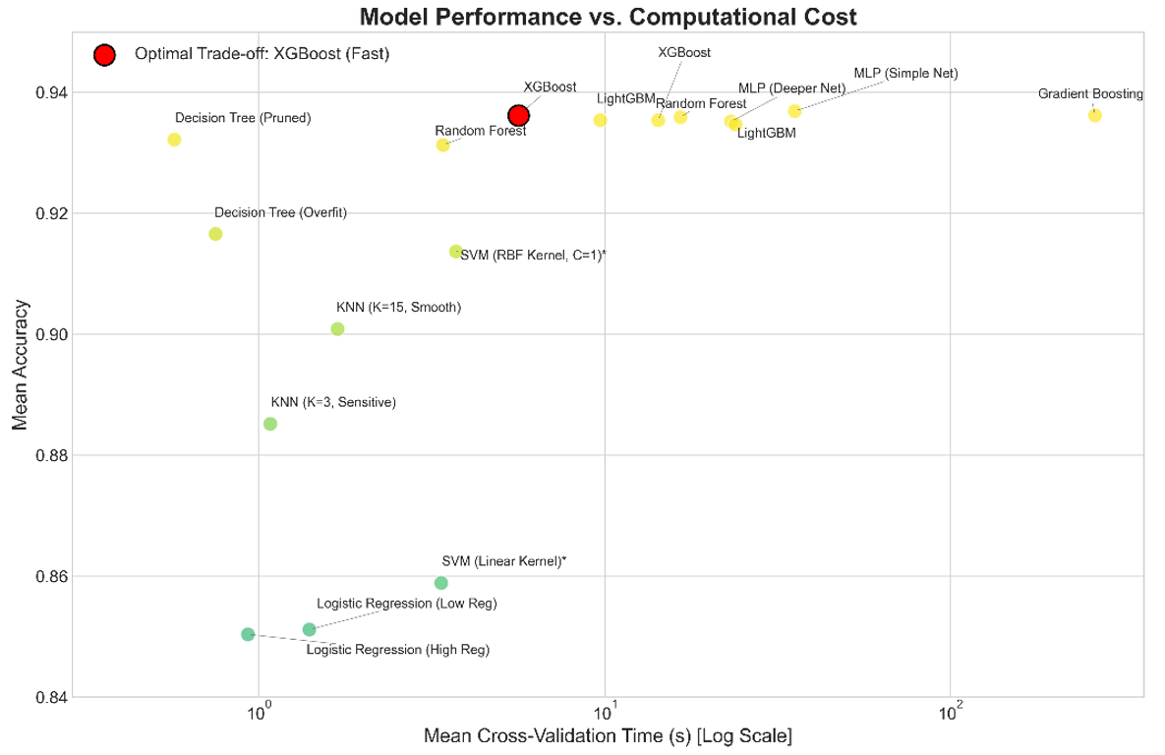
Figure X. Model performance versus computational cost for the 18 evaluated machine learning configurations, showing the trade-off between mean accuracy and mean cross-validation time.
To further assess the quality of the top-performing models, additional classification metrics were compared for the five best models. The results showed that the leading models achieved closely aligned accuracy, precision, recall, and F1-score values. XGBoost Fast achieved 93.64% accuracy, 93.60% precision, 93.64% recall, and 93.61% F1-score, confirming that its performance was balanced and not dependent only on a single accuracy metric.
Table 7. Detailed classification metrics for the top five models
Model | Mean accuracy (%) | Mean precision (%) | Mean recall (%) | Mean F1-score (%)
MLP Simple Network | 93.66 | 93.68 | 93.66 | 93.64
XGBoost Fast | 93.64 | 93.60 | 93.64 | 93.61
Random Forest Accurate | 93.53 | 93.50 | 93.53 | 93.50
LightGBM Fast | 93.57 | 93.54 | 93.57 | 93.55
XGBoost Accurate | 93.56 | 93.52 | 93.56 | 93.53
Although the final ORCHESTRA predictive layer is implemented as an XGBoost regressor for the continuous maintenance urgency score, the classification-based screening confirms the suitability of XGBoost for this dataset. It shows that XGBoost performs competitively across maintenance prediction tasks while maintaining low computational cost. This makes it a suitable candidate for deployment in a broader predictive maintenance pipeline, particularly where rapid prediction is required before human review and PPO-based scheduling.

5.2 XGBoost Prediction Performance and Feature Importance
After the model comparison stage, the final XGBoost model was trained as a regression model to estimate the continuous predictive maintenance score. This score represents the maintenance urgency level used by the ORCHESTRA framework. The six input variables consisted of electrode force, welding current, ultrasonic inspection score, electrode tip temperature, robot encoder error, and vibration. The target variable was the predictive maintenance score on a scale from 0 to 100.
The final XGBoost regressor achieved strong predictive performance on the test set. The model obtained a mean squared error of 6.24, a mean absolute error of 1.68, and an R² score of 0.9953. These results indicate that the model was able to capture the relationship between the resistance spot welding condition variables and the continuous maintenance urgency score under the simulation conditions used in this study.
Table 8. XGBoost regression performance for maintenance urgency prediction
Metric | Value
Mean Squared Error | 6.24
Mean Absolute Error | 1.68
R² Score | 0.9953
The high R² value indicates that the model explained most of the variation in the maintenance urgency score. The low MAE suggests that the predicted maintenance urgency values were generally close to the target values. This level of performance is suitable for the proof-of-concept evaluation because the predictive model provides a stable input for the subsequent uncertainty-triggered human review and PPO-based scheduling stages.
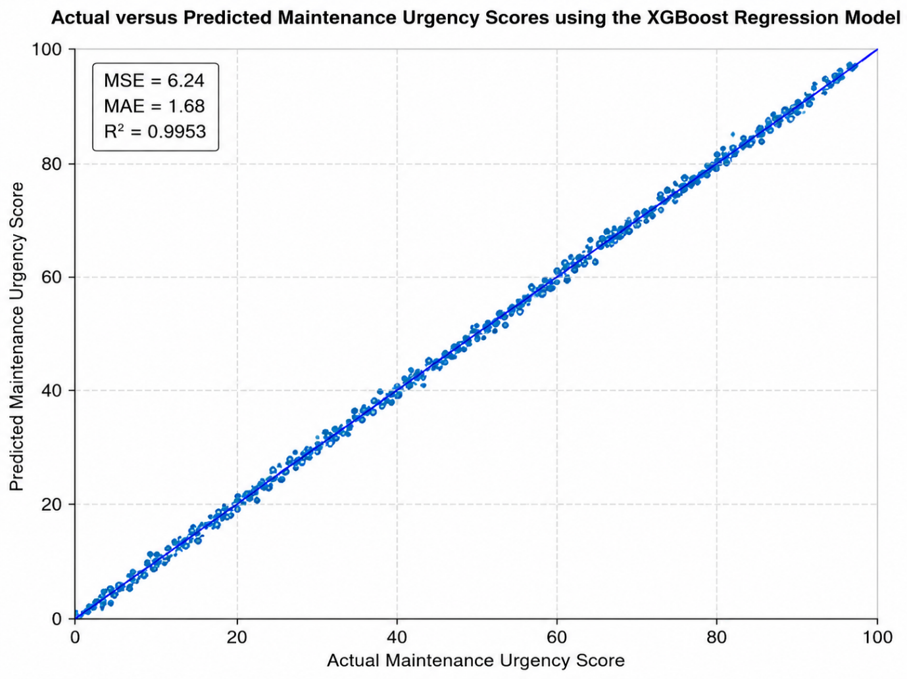
Figure X. Actual versus predicted maintenance urgency scores using the XGBoost regression model.
Beyond prediction accuracy, feature importance analysis was conducted to examine which process variables contributed most strongly to the XGBoost model predictions. This is important because a predictive maintenance model should not only produce accurate outputs, but should also provide engineering insight into the physical factors associated with degradation and maintenance need. The uploaded model evaluation identifies electrode tip temperature as the most dominant predictor, followed by vibration. Ultrasonic inspection score and robot encoder error are reported as secondary indicators, while electrode force and welding current contribute less strongly in the evaluated dataset.
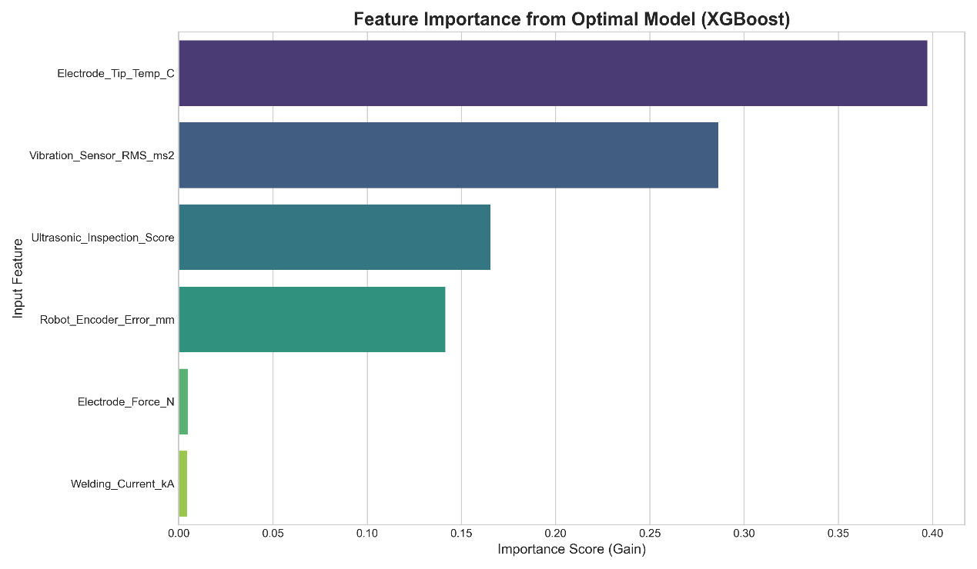
Figure X. Feature importance scores from the XGBoost maintenance urgency model.
The feature importance results suggest that thermal and vibration-related information are the strongest indicators of maintenance urgency in the evaluated resistance spot welding dataset. Electrode tip temperature is physically meaningful because excessive thermal accumulation may be associated with electrode wear, process instability, and changes in weld quality. Vibration is also relevant because increased vibration may indicate mechanical irregularity, robotic instability, or disturbance in the welding process. Together, these two variables form the primary predictive indicators used by the model.
A second group of variables, consisting of ultrasonic inspection score and robot encoder error, provided additional contextual information. These features may help distinguish between different forms of process instability, as the ultrasonic inspection score relates to weld integrity and robot encoder error reflects positional accuracy. Electrode force and welding current showed lower relative importance in the evaluated model. This does not mean that these variables are irrelevant to resistance spot welding. Rather, within the dataset used in this study, their predictive contribution was weaker or partly captured by the more dominant thermal and vibration-related features.
These findings support the engineering credibility of the XGBoost model. The model is not only achieving strong predictive performance, but is also relying on physically meaningful process variables. From a practical perspective, the results suggest that monitoring electrode tip temperature and vibration may be particularly valuable for maintenance decision support in resistance spot welding. This strengthens the role of the XGBoost model within ORCHESTRA, as its predictions can be supported by interpretable process indicators during human review.

5.3 Feature Importance Analysis
Beyond evaluating predictive performance, a feature importance analysis was conducted to examine which resistance spot welding variables contributed most strongly to the XGBoost model predictions. This analysis is important because predictive maintenance models should not only provide accurate outputs, but should also offer engineering insight into the physical factors associated with degradation and maintenance need. In the ORCHESTRA framework, this is particularly relevant because feature importance can support the Human Operator Agent by showing which process variables influenced the maintenance urgency prediction.
The feature importance analysis was performed using the selected XGBoost model. The importance scores represent the relative contribution of each input feature to the model’s prediction. The results indicate that the features can be grouped into three main levels of influence: primary predictors, secondary indicators, and lesser contributors.
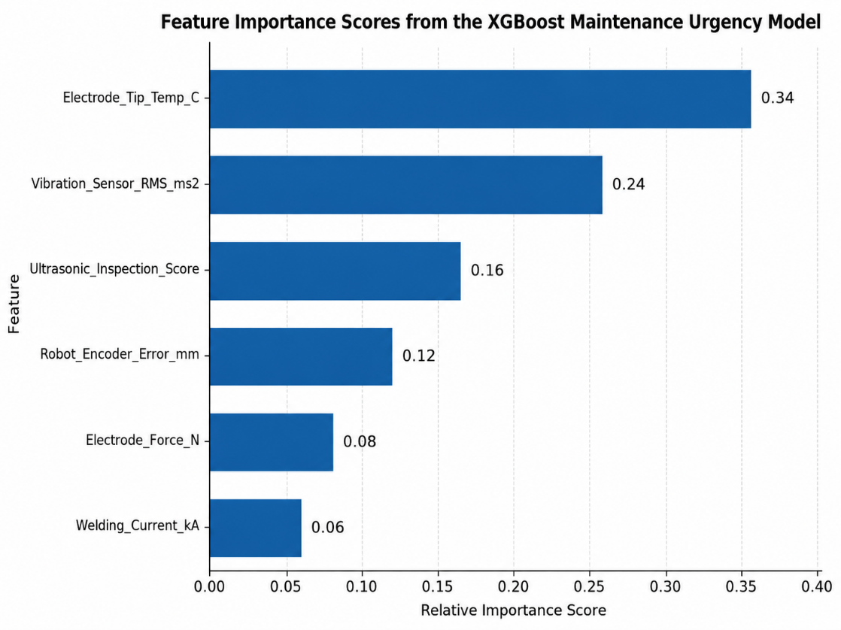
Figure X. Feature importance scores from the XGBoost maintenance urgency model.
The most influential variable was Electrode_Tip_Temp_C, which emerged as the dominant predictor of maintenance need. This indicates that electrode temperature plays a central role in the model’s estimation of maintenance urgency. From an engineering perspective, this is physically meaningful because excessive electrode tip temperature may be associated with heat accumulation, electrode wear, reduced process stability, and changes in weld quality. The second most influential variable was Vibration_Sensor_RMS_ms2, suggesting that vibration also provides important information about machine condition. Increased vibration may reflect mechanical instability, robot movement irregularity, or process disturbance. Together, electrode tip temperature and vibration formed the primary predictive indicators in the model.
The second group of variables consisted of Ultrasonic_Inspection_Score and Robot_Encoder_Error_mm. Although these features were less dominant than temperature and vibration, they provided useful contextual information for maintenance prediction. The ultrasonic inspection score relates to weld integrity, while robot encoder error reflects positional deviation. These variables may help the model distinguish between different forms of process instability and support more refined maintenance urgency estimation.
The features with the lowest relative contribution were Electrode_Force_N and Welding_Current_kA. This does not mean that electrode force and welding current are irrelevant to resistance spot welding. Rather, within the evaluated dataset, their predictive signal was weaker or partly represented through the more influential thermal and vibration-related variables. This interpretation is important because feature importance reflects the behaviour of the model within the specific dataset used in this study, rather than providing a universal ranking of all resistance spot welding variables.
Table X. Interpretation of XGBoost feature importance results
Feature group | Variables | Interpretation
Primary predictors | Electrode_Tip_Temp_C; Vibration_Sensor_RMS_ms2 | Main indicators of maintenance need; associated with thermal accumulation, electrode wear, mechanical instability, and process disturbance
Secondary indicators | Ultrasonic_Inspection_Score; Robot_Encoder_Error_mm | Provide contextual information related to weld integrity and positional accuracy
Lesser contributors | Electrode_Force_N; Welding_Current_kA | Lower relative contribution in the evaluated dataset; may be partly captured by thermal and vibration-related variables
These findings strengthen the credibility of the XGBoost model because its predictions are supported by physically meaningful process variables. The dominance of electrode tip temperature and vibration suggests that monitoring thermal and mechanical behaviour may be particularly important for predictive maintenance in resistance spot welding. From a practical perspective, this could support tighter temperature alert thresholds, improved vibration monitoring, and more targeted inspection of electrode condition.
The feature importance results also support the human-centred logic of ORCHESTRA. When the Human Operator Agent is activated, the system can present not only the predicted maintenance urgency score, but also the main variables influencing the prediction. This makes the review process more transparent and allows the operator to assess whether the model output is consistent with observed process behaviour. In this way, feature importance provides a bridge between the predictive model and practical maintenance decision-making. The model evaluation document explicitly identifies feature importance as a way to connect the machine learning model with practical maintenance strategies, especially by prioritising temperature and vibration monitoring.

5.4 PPO Scheduling Performance

The next stage of the evaluation examined the performance of the PPO-based RL Scheduling Agent. The purpose of this experiment was to evaluate whether the scheduling agent could translate maintenance urgency, uncertainty, resource availability, production load, time since last maintenance, and maintenance cost into proactive maintenance timing decisions.

The PPO agent was evaluated over multiple simulation episodes, with each episode consisting of 100 sequential maintenance decision steps. At each step, the agent selected one of five possible maintenance actions: no immediate action, immediate maintenance, maintenance during the next low-load production window, maintenance in three days, or maintenance in seven days. The results are summarised in Table X.

Table X. PPO scheduling performance results
Metric | Value
Mean episode reward | 614.39
Standard deviation of episode reward | 27.87
Mean critical failures | 0.00
Mean unnecessary maintenance actions | 0.30
Mean downtime proxy | 6.67
Mean cost proxy | 28.08
Action 2: Low-load window scheduling | 22.36%
Action 3: Maintenance in three days | 20.70%
Action 4: Maintenance in seven days | 56.94%

The PPO agent achieved a mean episode reward of 614.39, with a standard deviation of 27.87. This indicates that the learned policy produced consistently positive scheduling performance across the evaluation episodes. More importantly, the agent achieved an average of 0.00 critical failures, suggesting that the learned policy was able to avoid allowing the simulated resistance spot welding system to reach a critical failure state during evaluation.

The action distribution indicates that the PPO agent learned a planning-oriented maintenance policy. The most frequently selected action was maintenance in seven days, accounting for 56.94% of decisions. This suggests that the agent often identified conditions where the machine could continue operating safely without immediate intervention. The second most common action was maintenance during the next low-load production window, selected in 22.36% of decisions. This shows that the agent was able to use production context to avoid unnecessary disruption. Maintenance in three days represented 20.70% of decisions, indicating that the agent also recognised intermediate-risk cases where maintenance should not be postponed for too long.

Interestingly, the trained policy did not select Action 0, no immediate action, or Action 1, immediate maintenance, during the final evaluation. This suggests that the reward function encouraged the PPO agent to prefer planned maintenance actions rather than extreme decisions. In practical terms, the agent did not simply wait passively, nor did it rely on immediate intervention. Instead, it favoured scheduled maintenance actions that balanced risk reduction, downtime, and cost.

The low mean unnecessary maintenance value of 0.30 further supports this interpretation. A poor scheduling policy could avoid failures by scheduling maintenance too frequently, but this would increase cost and downtime. In contrast, the PPO agent avoided critical failures while maintaining a low number of unnecessary interventions. This suggests that the RL Scheduling Agent learned a useful trade-off between maintenance risk and operational efficiency.

Overall, these results support the feasibility of using PPO as the scheduling layer within ORCHESTRA. The agent did not simply reproduce a fixed maintenance rule. Instead, it learned differentiated maintenance timing behaviour and translated predictive and contextual information into proactive scheduling decisions.

5.5 Effect of Uncertainty-Triggered Human Review

The uncertainty-triggered human review mechanism was evaluated to examine how often the Human Operator Agent was activated and how frequently human input modified the decision process. In ORCHESTRA, human review is not applied to every maintenance decision. Instead, it is triggered when the system detects uncertainty, ambiguity, or operational sensitivity.

Each evaluation episode consisted of 100 decision steps. The results show that human review was triggered an average of 38.72 times per episode. This means that approximately 38.72% of decision steps required human review. The mean number of human overrides was 7.74 per episode, indicating that only a smaller proportion of reviewed cases required an actual refinement or correction.

Table X. Human review mechanism results
Metric | Value
Episode length | 100 decision steps
Mean human interventions per episode | 38.72
Human intervention rate | 38.72%
Mean human overrides per episode | 7.74
Override rate across all decisions | 7.74%
Override rate among reviewed cases | 19.99%

The human intervention rate suggests that the review mechanism was selective rather than continuous. The operator was not involved in every decision, which helps reduce unnecessary workload. At the same time, the system still activated human review in a substantial proportion of cases, particularly when uncertainty or ambiguity was present. This supports the human-centred logic of ORCHESTRA, where the operator is treated as an active decision-making agent but is not overloaded with routine low-risk cases.

The override results provide a second useful insight. Although human review was triggered in approximately 39% of decision steps, only around 20% of reviewed cases resulted in an override. This suggests that the Human Operator Agent often served as a validation layer rather than constantly changing the model output. In practical terms, this is desirable because it means the framework can preserve automation while still allowing human judgement to refine decisions when needed.

These findings support the value of uncertainty-triggered human review. Fully automated scheduling may be efficient, but it may ignore contextual information that is not captured by sensor data. Conversely, requiring human review for every prediction would increase workload and reduce system efficiency. ORCHESTRA provides a middle position by activating human review only when uncertainty or operational sensitivity is detected.

The results therefore show that the Human Operator Agent contributes to the framework as a selective refinement mechanism. It supports transparency, allows contextual judgement to enter the scheduling process, and helps ensure that uncertain cases are reviewed before final maintenance actions are selected.

5.6 Baseline Comparison
A baseline comparison was conducted to evaluate the performance of the proposed ORCHESTRA framework against alternative maintenance decision strategies. Seven strategies were compared under the same simulation conditions: reactive maintenance, fixed preventive maintenance, XGBoost-only alerting, XGBoost with human review, rule-based scheduling, PPO-only scheduling without human review, and the full ORCHESTRA framework. Each strategy was evaluated over 50 simulation episodes, with each episode consisting of 100 sequential maintenance decision steps.
The comparison considered mean episode reward, critical failure occurrence, unnecessary maintenance actions, downtime proxy, cost proxy, human intervention rate, and action distribution. The results are presented in Table X.
Table X. Baseline comparison results
Strategy | Mean reward | Critical failures | Unnecessary maintenance | Downtime proxy | Cost proxy | Human intervention rate
Reactive maintenance | -86.92 | 0.00 | 0.00 | 0.00 | 0.00 | 0.00%
Fixed preventive maintenance | -118.96 | 0.00 | 3.14 | 2.13 | 2.98 | 0.00%
XGBoost-only alert | 273.46 | 0.00 | 0.00 | 6.97 | 11.36 | 0.00%
XGBoost + Human Review | 267.36 | 0.00 | 0.00 | 6.88 | 11.20 | 38.42%
Rule-based scheduling | 434.49 | 0.00 | 0.00 | 6.02 | 25.90 | 0.00%
PPO-only scheduling | 613.90 | 0.00 | 0.40 | 6.66 | 28.07 | 0.00%
Full ORCHESTRA | 608.60 | 0.00 | 0.40 | 6.55 | 27.93 | 38.66%
The results show a clear difference between traditional maintenance strategies and adaptive decision-making strategies. Reactive maintenance achieved a negative mean reward of -86.92. This result reflects the limitation of waiting until the system approaches a critical condition before acting. Although no critical failures were recorded during the evaluation, the reactive strategy selected no immediate action in all cases and therefore failed to generate proactive maintenance value.
Fixed preventive maintenance achieved the lowest mean reward, with a value of -118.96. This strategy scheduled maintenance at fixed intervals regardless of the machine condition. As a result, it produced 3.14 unnecessary maintenance actions per episode. This demonstrates the limitation of time-based maintenance in the simulated environment, where maintenance may be performed even when the predicted condition does not justify intervention.
The XGBoost-only alert strategy achieved a higher mean reward of 273.46, showing that prediction-based decision-making provides a clear improvement over reactive and fixed preventive strategies. This strategy used the predicted maintenance severity to trigger maintenance actions, which allowed the system to respond to condition information. However, it remained limited because it used threshold-based action selection rather than adaptive scheduling. It could identify risk, but it did not optimise maintenance timing according to production load, resource availability, cost, or uncertainty.
The XGBoost + Human Review strategy achieved a mean reward of 267.36. This was slightly lower than the XGBoost-only strategy, but it reduced the downtime proxy from 6.97 to 6.88 and the cost proxy from 11.36 to 11.20. It also introduced human review in 38.42% of decision steps. This suggests that human review provided a contextual refinement layer, but its effect was limited when the final scheduling logic still relied on fixed threshold rules. In other words, human review alone did not substantially improve the reward outcome unless it was connected to a more adaptive scheduling mechanism.
Rule-based scheduling achieved a mean reward of 434.49, outperforming both XGBoost-only configurations. This indicates that deterministic rules using severity and operational variables can improve maintenance decision-making compared with simple alert-based strategies. However, rule-based scheduling remained less effective than PPO-based scheduling because it could not learn from repeated interaction with the simulated environment. Its action distribution was also strongly concentrated on delayed maintenance in seven days, which represented 77.46% of its decisions.
The PPO-only strategy achieved the highest mean reward, with a value of 613.90. This indicates that the reinforcement learning agent learned a strong planning-oriented maintenance policy. The PPO agent avoided critical failures while selecting planned maintenance actions across low-load window scheduling, three-day scheduling, and seven-day scheduling. This confirms that the scheduling layer added substantial value beyond prediction-only and rule-based approaches.
The full ORCHESTRA framework achieved a mean reward of 608.60, which was very close to the PPO-only strategy. Although its reward was slightly lower, Full ORCHESTRA introduced uncertainty-triggered human review in 38.66% of decision steps and human overrides in 7.12% of decision steps. It also achieved slightly lower downtime and cost proxies than PPO-only scheduling. This suggests that the Human Operator Agent did not destabilise the PPO scheduling policy and allowed contextual review to be integrated without a major performance penalty.
The action distribution results further clarify the behaviour of each strategy. Reactive maintenance selected no immediate action in 100% of cases, while fixed preventive maintenance selected no immediate action in 96% of cases and immediate maintenance in 4% of cases. XGBoost-only alerting mainly selected no immediate action, while using low-load window scheduling in 21.46% of cases. Rule-based scheduling, PPO-only scheduling, and Full ORCHESTRA showed more planning-oriented behaviour, with greater use of delayed and low-load maintenance actions.
Table X. Action distribution across baseline strategies
Strategy | Action 0: No action | Action 1: Immediate | Action 2: Low-load window | Action 3: In 3 days | Action 4: In 7 days
Reactive maintenance | 100.00% | 0.00% | 0.00% | 0.00% | 0.00%
Fixed preventive maintenance | 96.00% | 4.00% | 0.00% | 0.00% | 0.00%
XGBoost-only alert | 77.56% | 0.98% | 21.46% | 0.00% | 0.00%
XGBoost + Human Review | 78.06% | 1.38% | 20.56% | 0.00% | 0.00%
Rule-based scheduling | 0.00% | 0.00% | 20.14% | 2.40% | 77.46%
PPO-only scheduling | 0.00% | 0.00% | 22.22% | 21.32% | 56.46%
Full ORCHESTRA | 0.00% | 0.00% | 21.86% | 21.10% | 57.04%
Overall, the baseline comparison shows that adaptive scheduling provides the strongest improvement in the simulated environment. Prediction-based strategies outperformed traditional reactive and preventive approaches, but PPO-based scheduling produced the highest reward values. Full ORCHESTRA achieved performance comparable to PPO-only scheduling while adding uncertainty-triggered human review and contextual refinement. Therefore, the results support the value of ORCHESTRA as a coordinated decision-support architecture rather than a prediction-only maintenance system.

Figure X. Baseline comparison of mean episode reward across maintenance decision strategies. 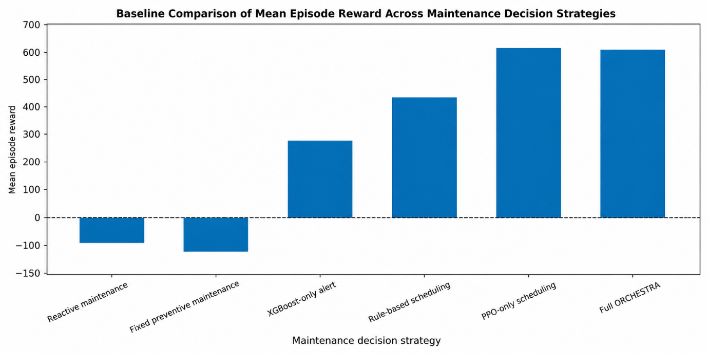

Figure X. Baseline comparison of action distributions across maintenance decision strategies. 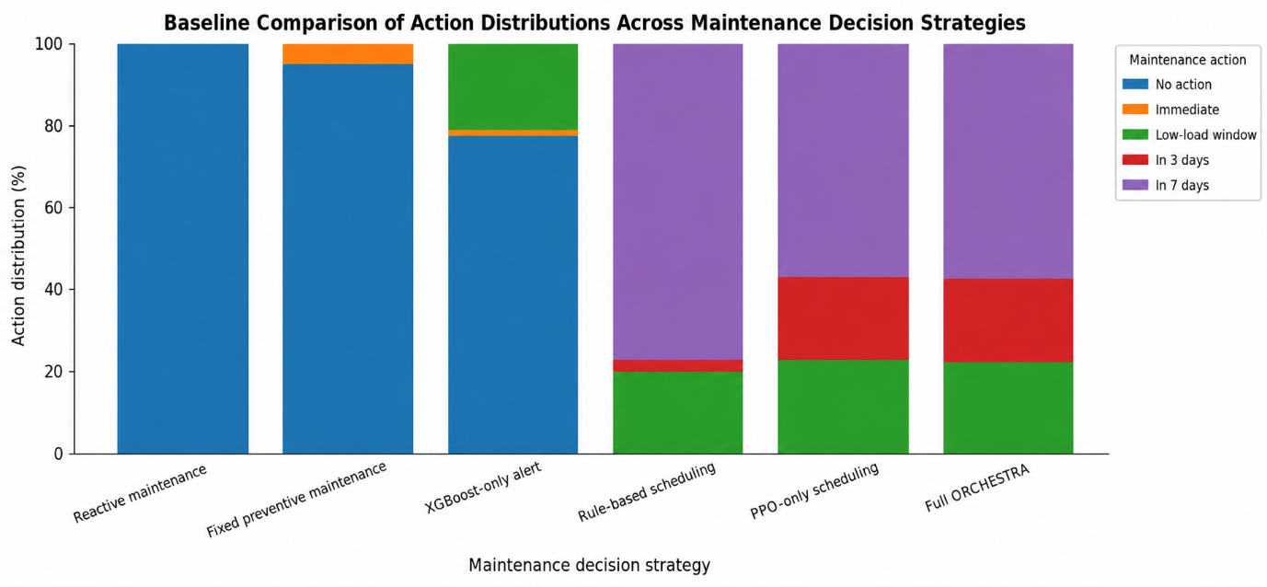

5.7 Ablation Study Results
An ablation study was conducted to examine the contribution of the main components within the ORCHESTRA framework. The purpose of this analysis was to determine whether the complete architecture provides added value beyond the individual use of prediction, human review, or reinforcement learning-based scheduling.
Four configurations were considered. The first configuration, XGBoost only, used the maintenance urgency prediction to trigger threshold-based maintenance actions without human review or PPO scheduling. The second configuration, XGBoost + Human Review, added the uncertainty-triggered Human Operator Agent but retained threshold-based scheduling. The third configuration, XGBoost + PPO, used the predictive output as input to the PPO Scheduling Agent but disabled human review. The fourth configuration, Full ORCHESTRA, integrated XGBoost-based maintenance urgency prediction, uncertainty-triggered human review, and PPO-based scheduling.
Table X. Ablation study results
Architecture | Mean reward | Critical failures | Unnecessary maintenance | Downtime proxy | Cost proxy | Human intervention rate
XGBoost only | 273.46 | 0.00 | 0.00 | 6.97 | 11.36 | 0.00%
XGBoost + Human Review | 267.36 | 0.00 | 0.00 | 6.88 | 11.20 | 38.42%
XGBoost + PPO | 613.90 | 0.00 | 0.40 | 6.66 | 28.07 | 0.00%
Full ORCHESTRA | 608.60 | 0.00 | 0.40 | 6.55 | 27.93 | 38.66%
The XGBoost-only configuration achieved a mean reward of 273.46. This confirms that the predictive layer provides useful condition awareness and can support maintenance decisions better than traditional reactive or fixed preventive approaches. However, the lower reward compared with the PPO-based configurations shows that prediction alone is not sufficient for effective maintenance scheduling. The model can estimate maintenance urgency, but it does not learn how to optimise the timing of maintenance actions under changing operational conditions.
The XGBoost + Human Review configuration achieved a mean reward of 267.36. This value was slightly lower than the XGBoost-only configuration, although it produced marginally lower downtime and cost proxies. This suggests that human review alone does not substantially improve the performance of a threshold-based scheduling strategy. The reason is that human contextual refinement can adjust the interpretation of uncertain cases, but the final decision remains limited by fixed action rules. Therefore, the benefit of human review is constrained when it is not connected to an adaptive scheduling mechanism.
The XGBoost + PPO configuration achieved the highest mean reward, with a value of 613.90. This shows that the PPO Scheduling Agent provides the largest individual performance improvement within the framework. By learning from repeated interaction with the simulated environment, the PPO agent was able to translate predicted maintenance severity and operational context into more effective maintenance timing decisions. Compared with XGBoost-only prediction, the addition of PPO increased the mean reward by more than double, from 273.46 to 613.90.
The Full ORCHESTRA configuration achieved a mean reward of 608.60, which was close to the XGBoost + PPO configuration. Although the reward was slightly lower, Full ORCHESTRA introduced human review in 38.66% of decision steps and human overrides in 7.12% of decision steps. It also achieved slightly lower downtime and cost proxies than XGBoost + PPO. This indicates that the Human Operator Agent can be integrated into the PPO-based scheduling pipeline without substantially reducing the performance of the learned policy.
The ablation results therefore indicate that the largest performance gain comes from adding reinforcement learning-based scheduling to the predictive layer. Human review alone has limited effect when paired only with threshold-based scheduling, but it adds a human-centred capability when integrated with PPO-based decision-making. This supports the main contribution of ORCHESTRA: the framework does not depend on a single algorithmic component, but on the coordination of predictive modelling, uncertainty-triggered human judgement, and adaptive maintenance scheduling.

Figure X. Ablation comparison of mean episode reward across ORCHESTRA configurations.
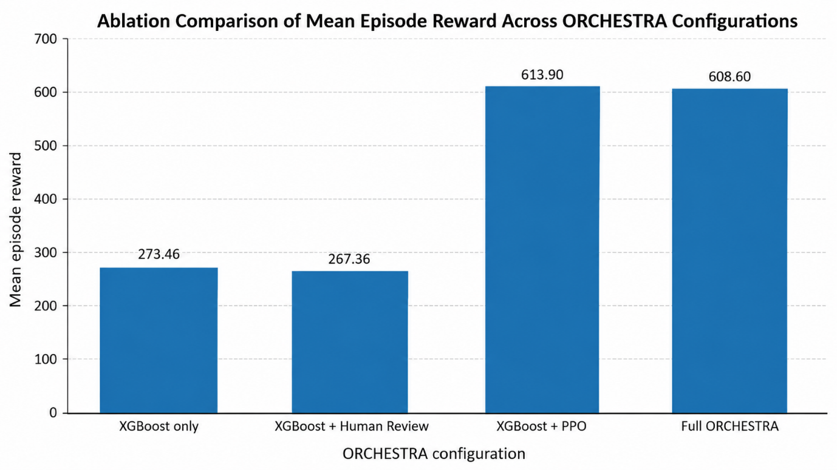
Figure X. Ablation comparison of downtime and cost proxy across ORCHESTRA configurations.
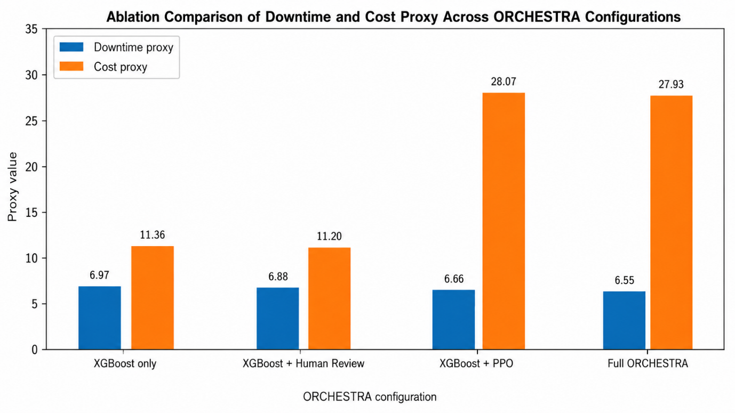
A careful interpretation is required. The results do not show that Full ORCHESTRA outperforms PPO-only scheduling in terms of reward. Instead, they show that Full ORCHESTRA maintains comparable scheduling performance while adding a selective human review layer. This is important because the objective of ORCHESTRA is not only to maximise reward, but also to support transparent, human-centred maintenance decision-making under uncertainty.

5.8 Sensitivity Analysis
A sensitivity analysis was conducted to examine the robustness of the full ORCHESTRA framework under different simulation assumptions. Four aspects were evaluated: uncertainty threshold, sensor noise, reward weight profile, and human intervention frequency. The purpose of this analysis was to determine whether the framework remained stable when the level of human review, input uncertainty, reward emphasis, and operator involvement were varied.
All sensitivity experiments were evaluated using the trained PPO Scheduling Agent under the same episode structure used in the previous experiments. Each evaluation consisted of 50 simulation episodes, with each episode containing 100 sequential maintenance decision steps. The main metrics considered were mean episode reward, critical failures, unnecessary maintenance actions, downtime proxy, cost proxy, human intervention rate, override rate, and action distribution.

5.8.1 Uncertainty Threshold Sensitivity
The first sensitivity experiment examined the effect of changing the uncertainty threshold used to trigger human review. Five threshold values were tested: 0.30, 0.50, 0.60, 0.70, and 0.90. A lower threshold makes the system more sensitive to uncertainty and therefore increases human involvement. A higher threshold reduces human involvement and allows more decisions to proceed directly to the PPO Scheduling Agent.
Table X. Sensitivity results for uncertainty threshold
Uncertainty threshold | Mean reward | Critical failures | Unnecessary maintenance | Downtime proxy | Cost proxy | Human intervention rate | Override rate
0.30 | 523.27 | 0.00 | 0.40 | 6.78 | 28.34 | 86.08% | 15.08%
0.50 | 582.59 | 0.00 | 0.30 | 6.75 | 28.11 | 53.94% | 9.40%
0.60 | 608.60 | 0.00 | 0.40 | 6.55 | 27.93 | 38.66% | 7.12%
0.70 | 622.92 | 0.00 | 0.44 | 6.06 | 27.65 | 27.46% | 5.02%
0.90 | 632.56 | 0.00 | 0.68 | 5.89 | 27.61 | 21.62% | 4.00%
The results show that increasing the uncertainty threshold reduced the human intervention rate from 86.08% at a threshold of 0.30 to 21.62% at a threshold of 0.90. This confirms that the uncertainty threshold effectively controls the level of human involvement in the decision process. The override rate followed the same trend, decreasing from 15.08% to 4.00% as the threshold increased.
The mean episode reward increased as the uncertainty threshold increased, rising from 523.27 at a threshold of 0.30 to 632.56 at a threshold of 0.90. This suggests that excessive human review may reduce scheduling efficiency in the current simulation, particularly when many cases are reviewed even though the PPO policy can handle them automatically. At the same time, all threshold settings achieved zero critical failures, indicating that the framework remained stable across the tested range.
From a human-centred perspective, the result does not necessarily mean that the highest threshold is always preferable. A high threshold reduces operator workload and improves reward in the simulation, but it also limits human involvement in ambiguous cases. A moderate threshold, such as 0.60 or 0.70, may therefore provide a more balanced setting by maintaining strong reward performance while preserving selective human review.
Figure X. Sensitivity of mean episode reward to uncertainty threshold.
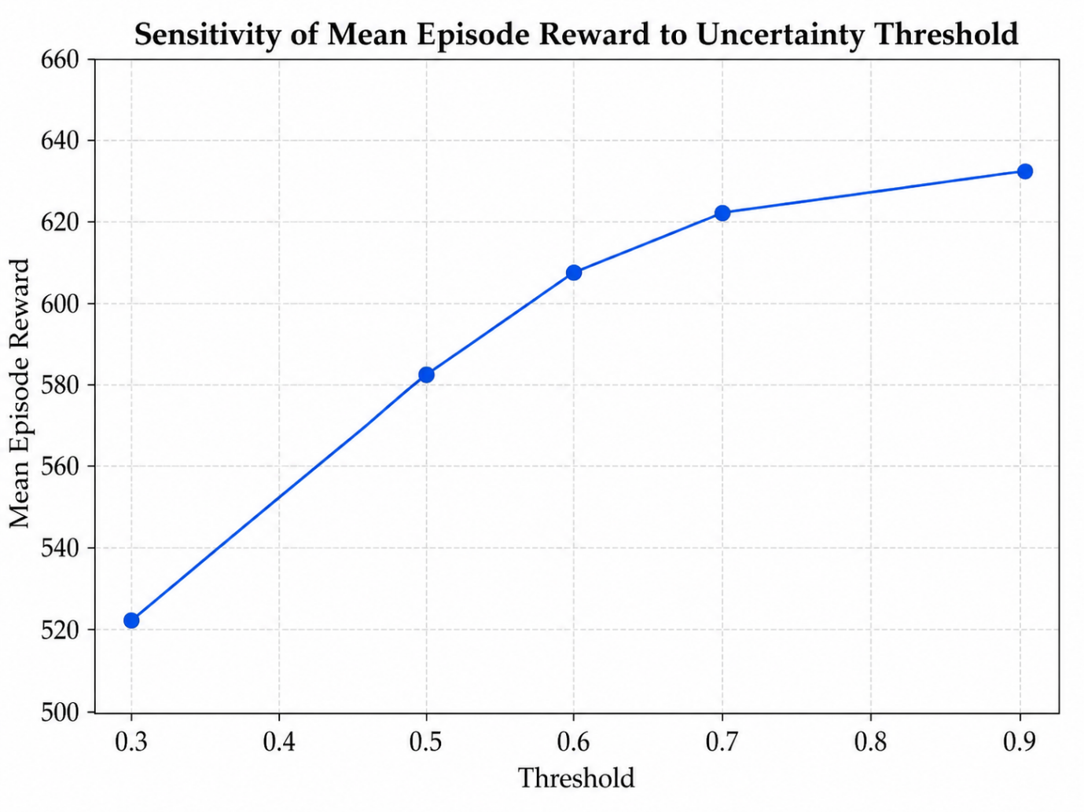

Figure X. Sensitivity of human intervention rate to uncertainty threshold.
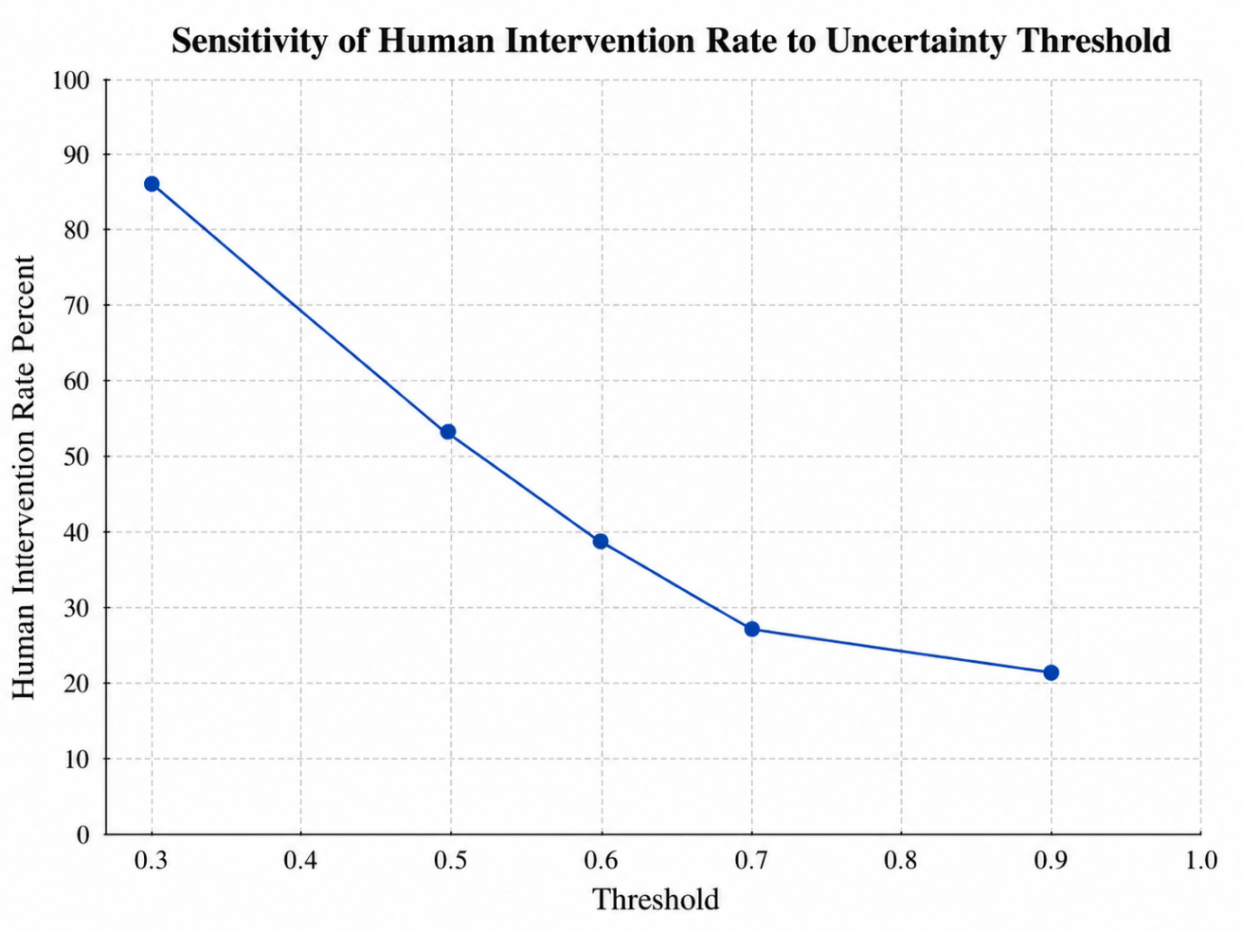

5.8.2 Sensor Noise Sensitivity
The second sensitivity experiment examined the effect of adding noise to the predicted maintenance severity signal. Four noise levels were evaluated: 0.00, 0.05, 0.10, and 0.20. This experiment was designed to assess whether the PPO scheduling policy remained stable when the input severity signal became less clean.
Table X. Sensitivity results for sensor noise
Noise standard deviation | Mean reward | Critical failures | Unnecessary maintenance | Downtime proxy | Cost proxy | Human intervention rate | Override rate
0.00 | 608.60 | 0.00 | 0.40 | 6.55 | 27.93 | 38.66% | 7.12%
0.05 | 614.79 | 0.00 | 0.22 | 6.98 | 28.33 | 39.54% | 7.14%
0.10 | 627.18 | 0.00 | 0.34 | 7.39 | 28.70 | 39.14% | 6.58%
0.20 | 645.46 | 0.00 | 0.28 | 9.02 | 30.11 | 39.90% | 7.28%
The results show that no critical failures occurred across any of the tested noise levels. This suggests that the scheduling policy remained robust under moderate and high perturbations to the severity signal. Human intervention remained relatively stable, ranging from 38.66% to 39.90%, which indicates that the human review mechanism was not excessively sensitive to noise under the tested conditions.
Interestingly, the mean episode reward increased as the noise level increased. This should be interpreted carefully. The increase in reward does not necessarily mean that noise improves the system. Rather, it suggests that the added noise shifted some severity values into ranges where the trained PPO policy selected actions that were more strongly rewarded by the current reward function. This is also reflected in the action distribution, where the use of low-load window scheduling increased from 21.86% at no added noise to 30.26% at the highest noise level.
However, the higher reward under noise came with higher downtime and cost proxies. Downtime increased from 6.55 to 9.02, and cost increased from 27.93 to 30.11. Therefore, while the framework remained failure-free under noisy inputs, higher noise also produced more operational activity and higher maintenance-related cost. This suggests that future development should test noise robustness using real sensor perturbations and should examine whether the reward function needs additional penalties for overreacting to noisy severity signals.
Figure X. Sensitivity of mean episode reward to sensor noise.
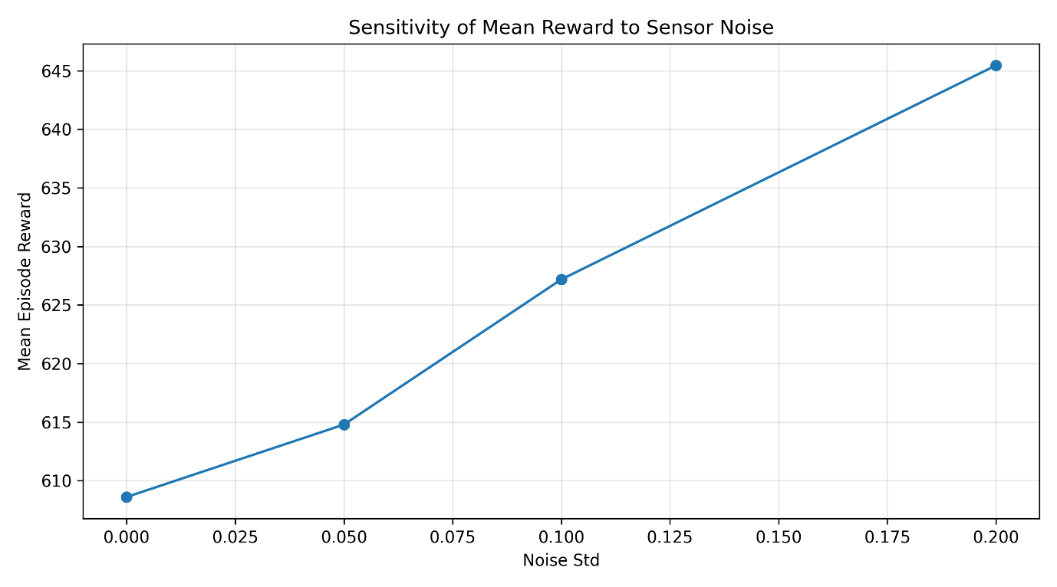

Figure X. Sensitivity of critical failures to sensor noise.
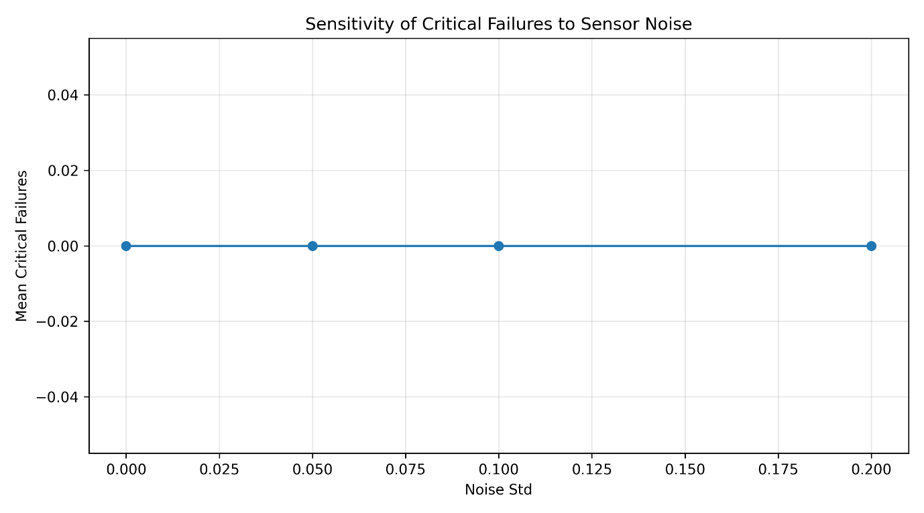

5.8.3 Reward Weight Sensitivity
The third sensitivity experiment examined how the trained PPO policy was scored under different reward weight profiles. Four profiles were tested: balanced, risk-focused, cost-focused, and uncertainty-focused. The balanced profile corresponds to the default reward configuration. The risk-focused profile increased the penalty for failure and high-risk delays. The cost-focused profile increased the penalty for unnecessary and disruptive maintenance. The uncertainty-focused profile increased the penalty associated with uncertain decisions.
Table X. Sensitivity results for reward weight profiles
Reward profile | Mean reward | Critical failures | Unnecessary maintenance | Downtime proxy | Cost proxy | Human intervention rate | Override rate
Balanced | 608.60 | 0.00 | 0.40 | 6.55 | 27.93 | 38.66% | 7.12%
Risk-focused | 602.53 | 0.00 | 0.40 | 6.55 | 27.93 | 38.66% | 7.12%
Cost-focused | 575.98 | 0.00 | 0.40 | 6.55 | 27.93 | 38.66% | 7.12%
Uncertainty-focused | 506.96 | 0.00 | 0.40 | 6.55 | 27.93 | 38.66% | 7.12%
The reward profile experiment shows that the same scheduling behaviour receives different scores depending on the reward priorities. The balanced profile achieved the highest reward among the tested scoring profiles, with a mean reward of 608.60. The risk-focused profile produced a similar reward of 602.53, suggesting that the learned policy was already compatible with risk-aware scheduling. The cost-focused profile reduced the reward to 575.98, while the uncertainty-focused profile produced the lowest reward of 506.96.
It is important to note that this experiment evaluated the same trained PPO policy under different reward-emphasis profiles. Therefore, the action distribution, downtime proxy, cost proxy, and human intervention rate remained constant across the four reward profiles. The purpose of this test was not to retrain PPO under each reward function, but to examine how sensitive the evaluation score is to different reward priorities. A stronger future extension would retrain a separate PPO model for each reward profile and compare whether the learned scheduling behaviour changes under different industrial priorities.
The results indicate that ORCHESTRA’s performance interpretation depends on the reward design. When uncertainty is penalised more heavily, the same policy receives a lower score. This reinforces the importance of carefully defining reward weights according to the operational priorities of the manufacturing environment.
Figure X. Sensitivity of mean episode reward to reward weight profiles.
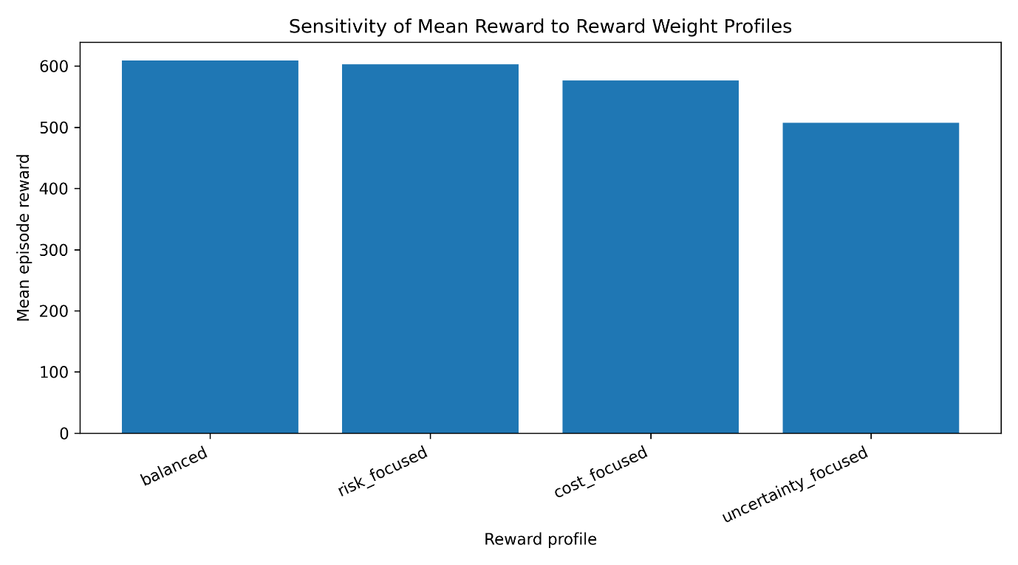

5.8.4 Human Intervention Frequency Sensitivity
The fourth sensitivity experiment examined the effect of forcing different levels of human review. Unlike the uncertainty threshold experiment, where human review was triggered by the uncertainty logic, this experiment directly controlled the probability of human review. Six review frequencies were tested: 0.00, 0.20, 0.40, 0.60, 0.80, and 1.00.
Table X. Sensitivity results for human intervention frequency
Forced review frequency | Mean reward | Critical failures | Unnecessary maintenance | Downtime proxy | Cost proxy | Human intervention rate | Override rate
0.00 | 619.37 | 0.00 | 0.32 | 6.79 | 28.28 | 0.00% | 0.00%
0.20 | 615.06 | 0.00 | 0.44 | 6.70 | 28.19 | 19.44% | 3.40%
0.40 | 615.79 | 0.00 | 0.36 | 6.83 | 28.25 | 40.84% | 7.10%
0.60 | 619.27 | 0.00 | 0.24 | 6.82 | 28.46 | 60.28% | 10.90%
0.80 | 612.11 | 0.00 | 0.36 | 6.80 | 28.24 | 81.50% | 14.70%
1.00 | 624.10 | 0.00 | 0.44 | 7.48 | 28.85 | 101.00% | 18.26%
The results show that the human intervention rate increased approximately in line with the forced review frequency. The value of 101.00% under full forced review occurs because the simulation can trigger review during the initial state generation as well as during the 100 decision transitions. Therefore, in a fully forced-review setting, the number of review events can slightly exceed the number of decision steps.
The mean reward remained relatively stable across the tested human review frequencies, ranging from 612.11 to 624.10. This suggests that the PPO scheduling policy was not highly sensitive to the amount of human review when the human input acted as a refinement layer. All forced review frequencies also resulted in zero critical failures, indicating that the framework remained stable under different levels of operator involvement.
However, the results also show that increasing human involvement does not automatically improve performance. For example, the mean reward at 0.80 forced review frequency was lower than at 0.00, 0.40, 0.60, and 1.00. This suggests that the effect of human review depends on how the refined severity values interact with the PPO scheduling policy. In practice, this supports the use of selective human review rather than constant human involvement.
The main implication is that ORCHESTRA can support different levels of human involvement without destabilising the scheduling policy. This is important for practical deployment because different factories may prefer different balances between automation and operator control. However, the uncertainty-triggered mechanism remains preferable to arbitrary forced review because it activates human input based on decision ambiguity rather than a fixed intervention frequency.
Figure X. Sensitivity of mean episode reward to human review frequency.
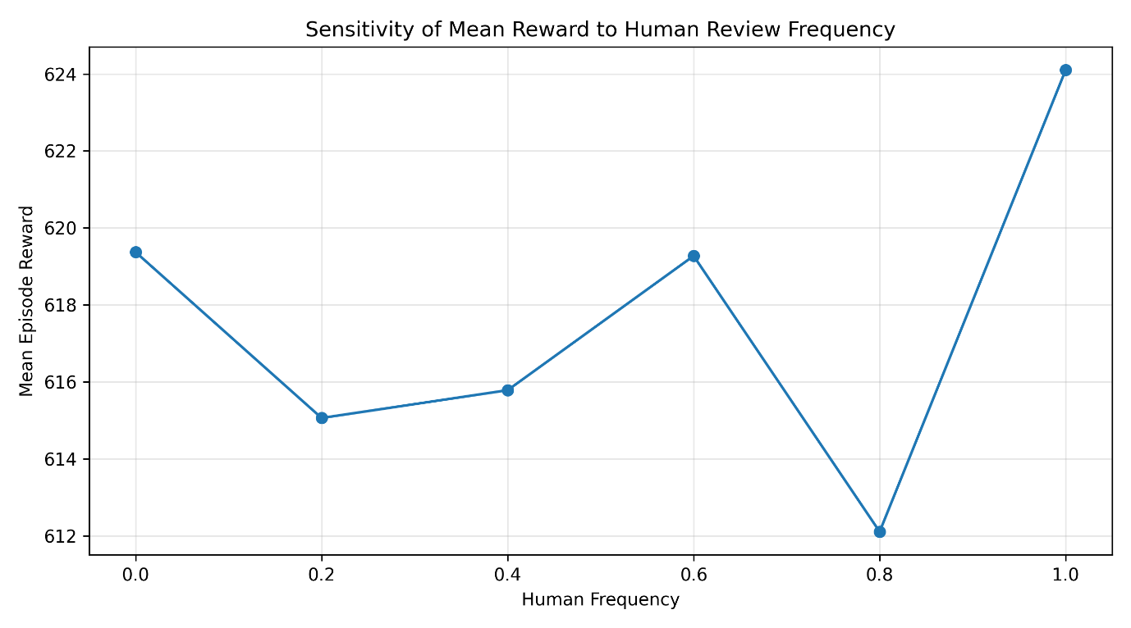
Figure X. Sensitivity of actual human intervention rate to forced review frequency.

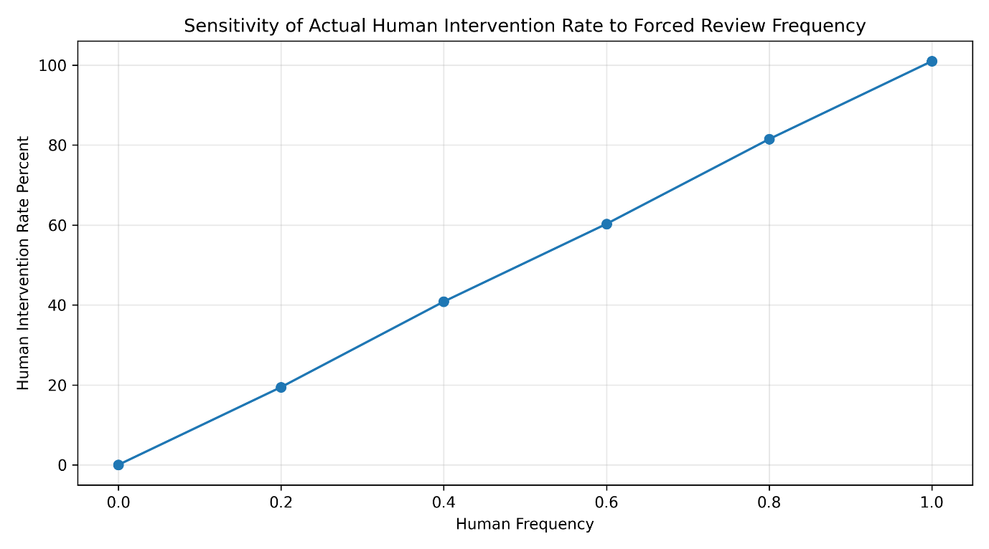

5.8.5 Summary of Sensitivity Findings
Overall, the sensitivity analysis shows that ORCHESTRA remained stable across the tested simulation variations. No critical failures occurred in any uncertainty threshold, sensor noise, reward profile, or human intervention frequency condition. This supports the robustness of the PPO Scheduling Agent within the simulated resistance spot welding maintenance environment.
The uncertainty threshold analysis showed that human workload can be controlled directly through the uncertainty threshold. Lower thresholds increased human involvement, while higher thresholds reduced operator workload and improved reward under the current reward formulation. The sensor noise analysis showed that the framework remained failure-free under increasing noise, although higher noise increased downtime and cost proxies. The reward weight analysis showed that the interpretation of PPO performance depends strongly on reward priorities, particularly when uncertainty is penalised heavily. Finally, the human intervention frequency analysis showed that the framework can tolerate different levels of operator involvement without major performance instability.
These results support the design logic of ORCHESTRA as a flexible human-centred decision-support framework. The framework does not depend on a single fixed level of automation. Instead, it can be adjusted according to the desired balance between reward performance, human workload, uncertainty management, maintenance cost, and operational disruption. A moderate uncertainty threshold remains a practical choice because it preserves selective human review while avoiding excessive operator involvement.

5.9 Summary of Results
The results support the feasibility of ORCHESTRA as a simulation-based human-centred multi-agent framework for predictive maintenance decision support in resistance spot welding. The evaluation showed that the proposed architecture can connect maintenance urgency prediction, uncertainty-triggered human review, and reinforcement learning-based scheduling within a single coordinated decision process.
The machine learning comparison demonstrated that XGBoost provided a strong balance between predictive performance and computational efficiency. Although the simple MLP model achieved a slightly higher mean accuracy, XGBoost achieved similar performance with lower computational time and lower mean absolute error. This justified its selection as the AI Predictive Agent within ORCHESTRA. The final XGBoost regressor achieved strong predictive performance for the continuous maintenance urgency score, with low error and a high coefficient of determination. The feature importance analysis further supported the engineering credibility of the model by identifying electrode tip temperature and vibration as the most influential predictors of maintenance urgency.
The PPO Scheduling Agent translated predictive and contextual information into proactive maintenance timing decisions. The PPO policy achieved a positive mean episode reward, avoided critical failures, and selected planned maintenance actions rather than relying on extreme decisions such as constant no-action or immediate maintenance. The action distribution showed a clear preference for maintenance in seven days, followed by low-load window scheduling and maintenance in three days. This indicates that the scheduling agent learned a planning-oriented policy that balanced maintenance risk, downtime, cost, and production disruption.
The uncertainty-triggered human review mechanism provided a selective method for including human judgement in the decision process. Human review was triggered in approximately 39% of decision steps under the main ORCHESTRA configuration, while overrides occurred in a smaller proportion of cases. This suggests that the Human Operator Agent functioned primarily as a validation and refinement layer rather than as a continuous manual control mechanism. This is important because it supports the human-centred logic of ORCHESTRA while avoiding excessive operator involvement.
The baseline comparison showed that adaptive scheduling strategies performed better than traditional reactive, fixed preventive, and prediction-only strategies. Reactive and fixed preventive maintenance produced negative rewards, while XGBoost-only alerting and rule-based scheduling improved performance but remained limited by threshold-based decision logic. PPO-only scheduling achieved the highest mean reward, while Full ORCHESTRA achieved comparable reward performance and added uncertainty-triggered human review. This result is important because it shows that ORCHESTRA should not be interpreted as simply outperforming PPO-only scheduling in numerical reward. Rather, its value lies in maintaining strong scheduling performance while adding a human-centred review mechanism for uncertain or operationally sensitive cases.
The ablation study confirmed that the largest performance gain came from adding PPO-based scheduling to the predictive layer. XGBoost-only and XGBoost with human review provided condition awareness and contextual refinement, but their performance remained limited when final decisions were still made through threshold-based rules. In contrast, XGBoost + PPO and Full ORCHESTRA achieved much stronger reward performance. Full ORCHESTRA maintained performance close to XGBoost + PPO while integrating selective human review, confirming that the Human Operator Agent can be included without substantially destabilising the learned scheduling policy.
Finally, the sensitivity analysis showed that ORCHESTRA remained stable across variations in uncertainty threshold, sensor noise, reward weight profile, and human intervention frequency. No critical failures occurred across the tested sensitivity conditions. The uncertainty threshold analysis showed that human workload can be controlled directly by adjusting the review threshold. The sensor noise analysis showed that the system remained failure-free under increasing noise, although higher noise increased downtime and cost proxies. The reward weight analysis showed that performance interpretation depends on the reward priorities, while the human intervention frequency analysis showed that ORCHESTRA can tolerate different levels of operator involvement without major instability.
Overall, the results demonstrate that ORCHESTRA is feasible as a framework-level contribution. The main value of the approach is not the individual use of XGBoost or PPO, but the way these tools are coordinated with uncertainty-triggered human review in a multi-agent predictive maintenance architecture. The findings provide simulation-based evidence that prediction, human judgement, and adaptive scheduling can be integrated to support more transparent and context-aware maintenance decision-making in resistance spot welding. At the same time, the results should be interpreted as proof-of-concept evidence rather than full industrial validation, since the framework was evaluated in a simulated environment with a simulated human operator and simplified maintenance dynamics.

6. Discussion

6.1 Interpretation of Findings
The results demonstrate the feasibility of ORCHESTRA as a simulation-based human-centred multi-agent framework for predictive maintenance decision support in resistance spot welding. The framework was able to connect maintenance urgency prediction, uncertainty-triggered human review, and reinforcement learning-based scheduling within a single decision-support architecture. This is important because predictive maintenance systems often focus on estimating machine condition, but the practical maintenance problem also requires deciding when and how to act.
The machine learning results showed that XGBoost provided a strong predictive layer for estimating maintenance urgency. Although it was not the only high-performing model, it offered a favourable balance between predictive performance, mean absolute error, stability, and computational efficiency. This made it suitable for integration into the wider ORCHESTRA pipeline, where the predictive model must provide reliable outputs to support human review and scheduling decisions. The feature importance results also supported the engineering relevance of the predictive model, as electrode tip temperature and vibration were identified as the strongest contributors to maintenance urgency prediction. This aligns with the physical interpretation of resistance spot welding, where thermal accumulation, electrode wear, mechanical disturbance, and process instability can influence weld quality and maintenance need.
The PPO-based scheduling results showed that reinforcement learning can translate predictive and contextual information into proactive maintenance timing decisions. The trained policy avoided critical failures and selected planned maintenance actions rather than relying on immediate intervention or passive no-action behaviour. This suggests that the scheduling layer learned to balance risk reduction, downtime, cost, and production disruption. Therefore, the results support the argument that prediction alone is not sufficient for predictive maintenance. A maintenance urgency score must be converted into an operational decision, and this requires a scheduling mechanism that can consider context.
The human review results further support the human-centred logic of ORCHESTRA. Human review was triggered selectively rather than continuously, meaning that the Human Operator Agent was involved mainly when uncertainty or ambiguity was present. This is significant because it avoids the two extremes of full automation and constant manual review. Full automation may miss contextual factors known to operators, while constant human involvement may increase workload and reduce system efficiency. ORCHESTRA provides a middle position by activating human judgement when it is most likely to add value.

6.2 Contribution of ORCHESTRA as a Framework
The main contribution of this study is the ORCHESTRA framework itself. The novelty does not lie in proposing a new XGBoost algorithm or a new PPO algorithm. Instead, the value of ORCHESTRA lies in the coordination of established techniques into a human-centred decision-support architecture for predictive maintenance. XGBoost is used as the AI Predictive Agent, PPO is used as the RL Scheduling Agent, and the Human Operator Agent provides contextual refinement under uncertainty. Together, these components create a structured decision pipeline from process sensing to maintenance action.
This framework-level contribution is important because many predictive maintenance approaches remain model-centred. They focus on fault detection, remaining useful life prediction, or degradation estimation, but they do not always explain how predictions are converted into maintenance decisions. ORCHESTRA addresses this limitation by treating predictive maintenance as a multi-agent decision process. The machine provides condition data, the predictive model estimates maintenance urgency, the human operator reviews uncertain cases, and the scheduling agent selects a maintenance action.
The framework also contributes by formalising the interaction between prediction, human judgement, and scheduling. Rather than placing the operator outside the system as a passive recipient of alerts, ORCHESTRA represents the operator as an active agent within the architecture. This supports a more realistic view of smart manufacturing, where human expertise remains important even when advanced data-driven methods are available. In this sense, ORCHESTRA follows a human-centred automation logic: the aim is not to remove the operator, but to involve the operator selectively and meaningfully.
A further contribution is the context-aware formulation of the scheduling problem. The PPO agent does not simply act on a binary fault signal. It receives a state representation that includes predicted severity, uncertainty, production load, resource availability, time since last maintenance, and cost. This allows the scheduling decision to reflect both technical risk and operational feasibility. The framework therefore moves predictive maintenance from a prediction-only task towards an integrated decision-support process.

6.3 Added Value of Human Review
The results show that the addition of human review did not produce the highest numerical reward when compared with PPO-only scheduling. PPO-only achieved a slightly higher mean reward, while Full ORCHESTRA achieved comparable performance with added human review. This distinction is important. The purpose of the Human Operator Agent is not necessarily to maximise the reward in every simulation setting. Its purpose is to improve transparency, provide contextual validation, and support decision-making under uncertainty.
In the baseline and ablation results, human review alone did not substantially improve threshold-based decision-making. The XGBoost + Human Review configuration achieved a similar but slightly lower reward than XGBoost-only alerting, although it produced marginally lower downtime and cost proxies. This suggests that human review has limited value when the final action selection remains governed by simple threshold rules. In other words, human judgement may refine the prediction, but if the scheduling logic is rigid, the benefit of that refinement is constrained.
However, when human review was integrated with PPO-based scheduling, it provided a selective review layer without significantly destabilising the learned policy. Full ORCHESTRA maintained reward performance close to PPO-only scheduling while introducing human review in uncertain cases. This is valuable from a practical perspective because industrial maintenance decisions often involve factors that are not fully represented in sensor data. Operators may know whether a machine has recently been serviced, whether spare parts are available, whether production can tolerate a short delay, or whether an abnormal signal is linked to a known temporary condition.
The sensitivity analysis also showed that the level of human involvement can be controlled through the uncertainty threshold. Lower thresholds increased human intervention, while higher thresholds reduced workload and improved reward under the current simulation setting. This provides a useful design insight: the human review mechanism can be tuned according to the desired balance between automation and human oversight. In a safety-critical or high-cost environment, a lower threshold may be preferred. In a stable high-throughput environment, a higher threshold may reduce workload while maintaining acceptable performance.
Therefore, the added value of human review should be understood in terms of decision quality, interpretability, and operational trust, not only numerical reward. The Human Operator Agent gives ORCHESTRA a mechanism for dealing with ambiguity and contextual knowledge, which is particularly important for future industrial deployment.

6.4 Added Value of PPO Scheduling
The baseline and ablation results show that PPO-based scheduling was the largest contributor to performance improvement. The XGBoost-only alert strategy improved over reactive and fixed preventive maintenance, but it remained limited by threshold-based action selection. Rule-based scheduling improved further, but it still depended on manually defined decision thresholds. In contrast, PPO-based scheduling achieved the strongest overall reward performance by learning from repeated interaction with the maintenance environment.
This finding reinforces the argument that predictive maintenance requires more than accurate prediction. A model may estimate that a machine has medium or high maintenance urgency, but this does not automatically determine the correct operational action. Maintenance may be required immediately, during the next low-load window, in three days, or in seven days. The correct decision depends on the interaction between severity, uncertainty, production load, resource availability, cost, and time since last maintenance.
The PPO agent added value because it treated maintenance scheduling as a sequential decision-making problem. Rather than applying a static rule, it learned a policy that selected planned maintenance actions under different simulated conditions. The resulting action distribution showed that the agent avoided extreme decisions. It did not rely on constant immediate maintenance, which would increase cost and downtime, and it did not rely on constant no-action, which would increase risk. Instead, it favoured planned actions such as maintenance in seven days, low-load window scheduling, and maintenance in three days.
This behaviour is important for practical maintenance planning. In high-volume manufacturing environments, immediate maintenance is not always desirable, even when risk is present. Maintenance timing must be coordinated with production schedules, available personnel, cost, and operational priorities. The PPO Scheduling Agent provides a mechanism for learning this type of trade-off. Therefore, its value lies not only in improving reward, but in enabling predictive maintenance to become proactive and context-aware.

6.5 Lessons from Baseline and Ablation Results
The baseline comparison provides three main lessons. First, traditional maintenance strategies were not sufficient in the simulated environment. Reactive maintenance and fixed preventive maintenance produced negative rewards. Reactive maintenance failed to create proactive value because it waited too long before acting, while fixed preventive maintenance created unnecessary interventions because it acted at fixed intervals regardless of condition.
Second, prediction-based strategies improved performance but remained incomplete. The XGBoost-only alert strategy performed better than reactive and preventive maintenance because it used condition information to trigger actions. However, it did not optimise the timing of maintenance. This confirms that maintenance prediction and maintenance scheduling are related but distinct tasks. A prediction model can tell the system that risk is increasing, but it cannot by itself decide the most appropriate intervention timing.
Third, adaptive scheduling produced the strongest improvement. PPO-only scheduling and Full ORCHESTRA achieved the highest reward values. This confirms that the RL Scheduling Agent is central to the framework’s performance. However, the ablation results also show that Full ORCHESTRA should not be described as numerically outperforming PPO-only scheduling. Instead, the correct interpretation is that Full ORCHESTRA maintained comparable scheduling performance while adding uncertainty-triggered human review.
The ablation study further clarifies the role of each component. XGBoost provides condition awareness. Human review provides contextual refinement under uncertainty. PPO provides adaptive maintenance timing. The full framework combines all three. This supports the argument that ORCHESTRA’s contribution lies in integration. The framework is not simply a predictive model, a human-in-the-loop system, or a reinforcement learning scheduler. It is a coordinated architecture that connects these elements into a single maintenance decision-support process.

6.6 Practical Implications for Resistance Spot Welding
The proposed framework has practical implications for resistance spot welding because the process is sensitive to progressive degradation, thermal variation, mechanical instability, and process inconsistency. In industrial settings, these factors can affect weld quality, rework, downtime, and production cost. A framework that connects sensing, prediction, human judgement, and scheduling could support earlier and more structured maintenance decision-making.
The feature importance results suggest that electrode tip temperature and vibration may be particularly important monitoring signals for maintenance decision support. This could guide future sensor deployment by prioritising thermal and mechanical monitoring around the welding process. Ultrasonic inspection and robot encoder error also provide useful secondary information, particularly for weld integrity and positional accuracy. These findings suggest that predictive maintenance for resistance spot welding should consider both process quality indicators and machine condition indicators.
The PPO scheduling results also suggest that maintenance planning should not be limited to binary decisions. In practice, the question is not only whether maintenance is needed, but when it should be performed. ORCHESTRA’s action space reflects this by including immediate maintenance, maintenance during a low-load window, and delayed maintenance options. This type of structure may be useful in production environments where maintenance must be coordinated with throughput, labour availability, and production demand.
The human-centred design of ORCHESTRA is also relevant for implementation. Maintenance technicians and operators often have experience-based knowledge that is difficult to capture in a dataset. By including selective human review, the framework can support adoption by making the decision process more transparent and by allowing human expertise to remain part of the maintenance workflow. This may improve trust compared with a fully automated black-box scheduling system.

6.7 Limitations
Several limitations should be acknowledged. First, this study is based on a simulation-based proof-of-concept rather than a live industrial deployment. The dataset was adapted for the ORCHESTRA simulation, and some variables required for predictive maintenance scheduling were derived or simulated. Therefore, the results should be interpreted as evidence of framework feasibility rather than direct industrial validation.
Second, the Human Operator Agent was simulated. Although this allowed the study to test uncertainty-triggered human review in a controlled way, it does not fully represent the complexity of real operator judgement. Real human decisions may be influenced by experience, fatigue, trust in automation, production pressure, communication quality, and organisational procedures. Future studies should include real operators or maintenance experts to validate the human review mechanism.
Third, the PPO environment was simplified. The current implementation represents a single-machine maintenance scheduling problem with a limited set of state variables and five discrete actions. Real manufacturing environments may involve multiple welding stations, shared maintenance resources, spare-part constraints, production dependencies, and complex downtime costs. These factors should be considered in future versions of the framework.
Fourth, the reward function was designed for proof-of-concept evaluation. Although it includes penalties for failure, unnecessary maintenance, downtime, cost, and production disruption, the reward weights were not calibrated using industrial cost data. The sensitivity analysis showed that performance interpretation depends on the reward profile. This means that reward design should be adapted carefully for specific industrial environments.
Finally, the current study focuses on simulation evidence. The results show that ORCHESTRA can coordinate prediction, human review, and scheduling under controlled conditions, but they do not yet prove that the framework will achieve the same performance in a real production line. Live validation is required before making claims about industrial effectiveness.

6.8 Future Work
Future work should focus on moving ORCHESTRA from simulation-based proof-of-concept towards industrial validation. The first priority is to evaluate the framework using live resistance spot welding data, including directly measured degradation indicators, maintenance events, operator decisions, production load, and downtime records. This would allow the predictive and scheduling components to be tested under real operating conditions.
A second direction is to involve real human operators or maintenance engineers in the review process. This would make it possible to evaluate how operators interpret model outputs, when they choose to override predictions, and whether feature importance or explainability information improves trust and decision quality. A user-facing dashboard could also be developed to present maintenance urgency, uncertainty, feature importance, suggested scheduling action, and operator feedback options.
A third direction is to expand the PPO scheduling environment. Future versions should consider multi-machine scheduling, shared maintenance teams, spare-part availability, production sequencing, and dynamic cost models. This would make the framework more representative of industrial maintenance planning, where decisions are rarely made for one isolated machine.
A fourth direction is to strengthen explainability. In the current study, feature importance was used to support interpretation of the XGBoost model. Future work could integrate more advanced explainable AI methods to show why a particular urgency score or scheduling action was recommended. This would support the human-centred design of ORCHESTRA and make the Human Operator Agent more informed during review.
Finally, future research should compare different reinforcement learning algorithms, retrain PPO under different reward profiles, and test robustness under more realistic noise and sensor failure scenarios. This would provide a stronger understanding of how ORCHESTRA performs under different industrial priorities and operational constraints.

7. Conclusion
This paper proposed ORCHESTRA, a simulation-based human-centred multi-agent framework for predictive maintenance decision support in resistance spot welding. The study addressed the limitation of prediction-only maintenance systems by showing that maintenance urgency prediction must be connected to human judgement and proactive scheduling before it can support practical maintenance decision-making. In this context, the contribution of ORCHESTRA lies in the framework-level integration of machine sensing, maintenance urgency prediction, uncertainty-triggered human review, and reinforcement learning-based scheduling, rather than in the development of a new XGBoost or PPO algorithm.
The framework was implemented through four main agents: a Machine/IoT Agent, an AI Predictive Agent, a Human Operator Agent, and an RL Scheduling Agent. XGBoost was used as the predictive layer to estimate a continuous maintenance urgency score from resistance spot welding condition variables. The Human Operator Agent was activated under uncertain or ambiguous conditions to validate, refine, or override the predicted severity. The PPO Scheduling Agent then converted predictive and contextual information into one of five maintenance timing actions, including immediate maintenance, low-load window scheduling, and delayed maintenance options.
The results showed that XGBoost provided a strong and computationally efficient predictive model for the AI Predictive Agent. The final XGBoost regressor achieved low prediction error and a high coefficient of determination for the maintenance urgency score. Feature importance analysis identified electrode tip temperature and vibration as the most influential variables, which supports the engineering relevance of the predictive model for resistance spot welding maintenance decision support.
The PPO Scheduling Agent demonstrated the ability to learn a planning-oriented maintenance policy. It avoided critical failures in the simulation and selected planned maintenance actions rather than relying only on immediate maintenance or no-action decisions. The baseline comparison showed that PPO-based scheduling achieved substantially stronger performance than reactive maintenance, fixed preventive maintenance, XGBoost-only alerting, and rule-based scheduling. The ablation study further showed that the largest performance improvement came from adding PPO-based scheduling to the predictive layer.
The full ORCHESTRA configuration achieved performance comparable to PPO-only scheduling while adding uncertainty-triggered human review. This is an important finding because the purpose of ORCHESTRA is not only to maximise numerical reward, but also to support transparent and human-centred decision-making under uncertainty. The Human Operator Agent provided a selective review layer, allowing human judgement to be included without requiring constant manual intervention. The sensitivity analysis showed that the framework remained stable across variations in uncertainty threshold, sensor noise, reward weight profile, and human intervention frequency, with no critical failures observed across the tested conditions.
The study has several limitations. The framework was evaluated as a simulation-based proof-of-concept rather than through live industrial deployment. The dataset was adapted for the ORCHESTRA simulation, and some variables required for maintenance scheduling were derived or simulated. The Human Operator Agent was also simulated, meaning that the current results do not fully represent real operator behaviour, trust, workload, or decision-making under industrial pressure. In addition, the PPO environment focused on a simplified single-machine scheduling scenario and did not yet include multi-machine dependencies, shared maintenance teams, spare-part constraints, or real downtime cost data.
Future work should therefore validate ORCHESTRA using live resistance spot welding data, real maintenance records, and direct operator participation. Further development should include a human-facing dashboard, explainable AI outputs, real-time uncertainty visualisation, and multi-machine scheduling. The PPO environment should also be extended to include more realistic production constraints and reward weights calibrated from industrial cost and downtime data. Despite these limitations, the results provide initial evidence that ORCHESTRA can support the transition from prediction-only maintenance towards a coordinated, human-centred, and context-aware maintenance decision-support architecture for smart manufacturing.

References

src/
├── data_preprocessing/
│ └── preprocess_rsw_data.py
├── predictive_model/
│ └── train_xgboost_regressor.py
├── rl_scheduling/
│ └── train_ppo_agent.py
├── human_review/
│ └── human_review_rules.py
└── experiments/
└── sensitivity_analysis.py

ORCHESTRA-Predictive-Maintenance-RSW/
│
├── README.md
├── requirements.txt
├── data/
│ └── README.md
├── src/
│ ├── preprocess_data.py
│ ├── train_xgboost_regressor.py
│ ├── train_ppo_agent.py
│ ├── baseline_comparison.py
│ └── sensitivity_analysis.py
├── results/
│ ├── ppo_evaluation_results.csv
│ ├── baseline_comparison_results.csv
│ └── sensitivity_results/
├── figures/
│ └── paper_figures/
└── docs/
├── reward_function.md
├── baseline_rules.md
└── ppo_environment.md

data/ = dataset instructions or data files
results/ = CSV results from experiments
figures/ = plots and images for the paper
models/ = trained XGBoost or PPO models
docs/ = explanation files and reproducibility notes
src/ = Python source code

